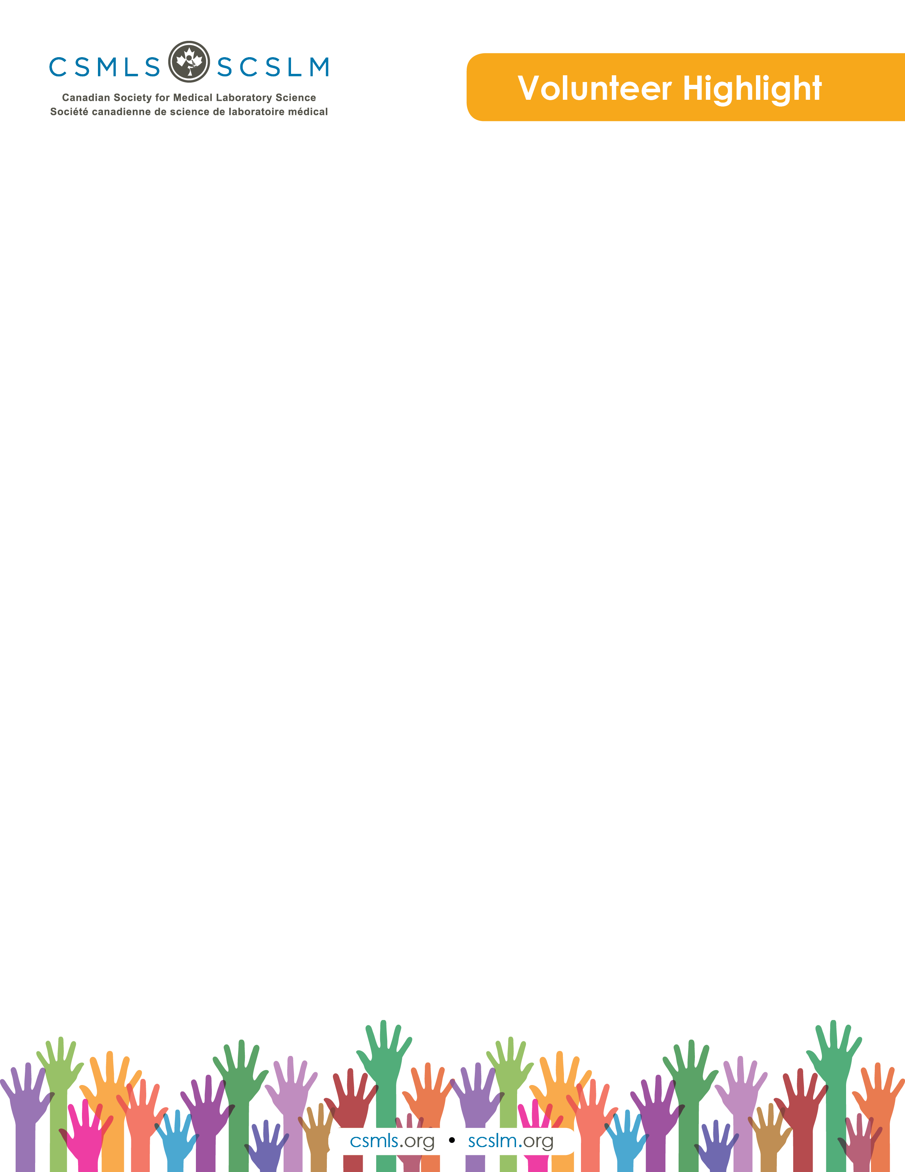

Kimberly Wheelans

I have been involved in education for more than 20 years as an educator, a practica coordinator and, currently, as a manager of allied health programs at Southern Alberta Institute of Technology in Calgary, Alberta. My passion for education led me to completing my Masters in Education. I enjoy meeting people through volunteering on provincial or national committees. In my spare time, I enjoy photography, curling and traveling with my husband.

What is your involvement with the CSMLS Research and Special Initiatives Department?

My background as a practica coordinator and a chair for a research ethics board led me to participating in CSMLS initiatives and discussions on education, research projects, accreditation and simulation. I am a participant on the CSMLS Educator Committee, and I enjoy working with a diverse group of educators across Canada in looking for ways to improve education, competency profiles or using simulation.

Why do you value your partnership and project(s) with CSMLS?

Working with CSMLS allows for sharing of ideas on research, preceptor education or simulation. This is an amazing way to hear how others across Canada are managing challenges faced in education for medical laboratory assistant and technology professions. Working with others who have a passion for improving education is very rewarding, and CSMLS is offering a venue for discussions, webinars and groups to get together.

How will your project(s) help the medical laboratory profession?

I believe in volunteering and participating in making changes through collaboration. The more involvement we have from across Canada from representatives from the lab profession, such as educators, students, employers and professionals, the more we will make the learning environment better and, ultimately, a more successful graduate and professional. We are currently sharing best practices on how to support preceptors through education or uses of simulation in education as an effective learning environment.