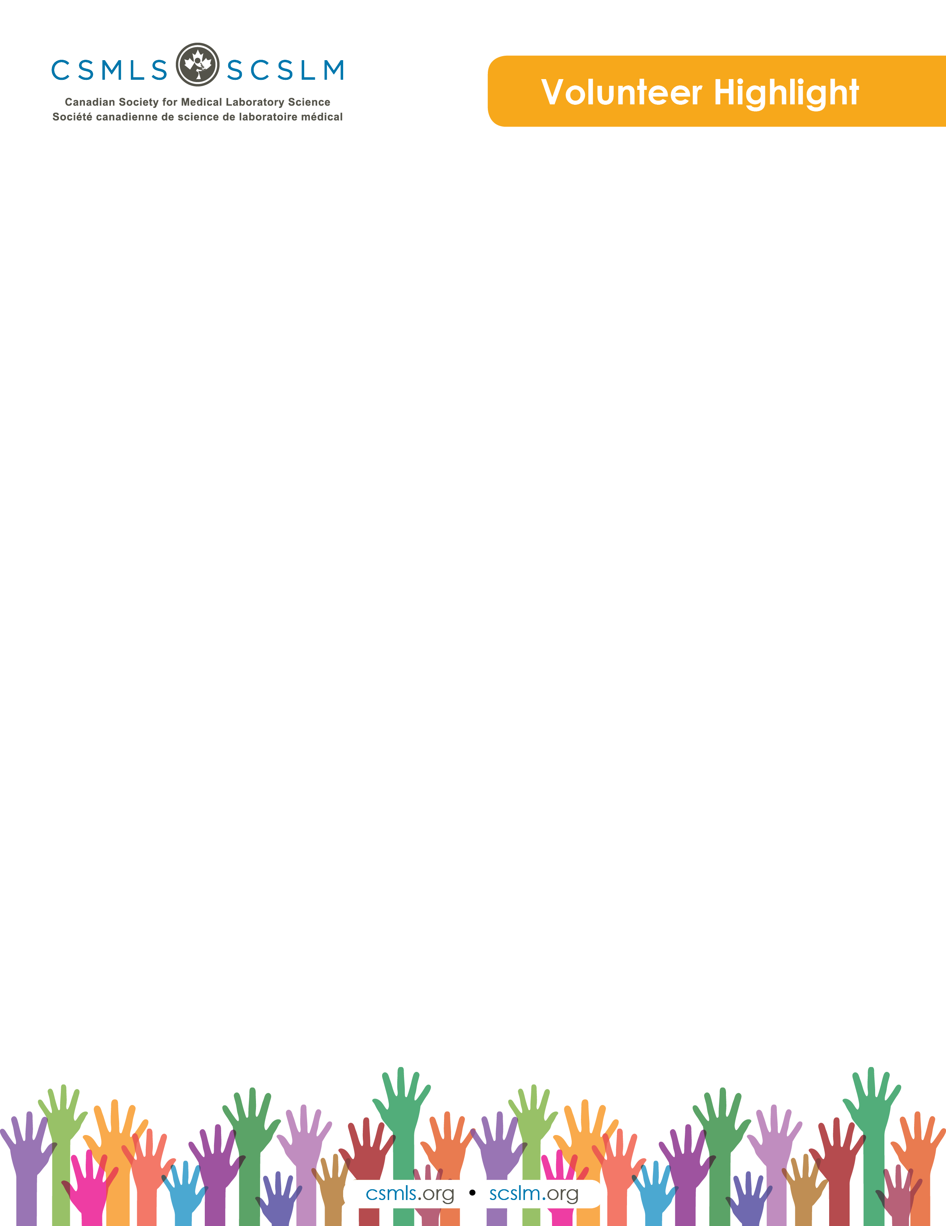

Amanda VanSpronsen

Currently, I am an Associate Professor in the Medical Laboratory Science program at the University of Alberta. For much of my time, I’m fortunate to teach and be inspired by the next generation of MLTs. I’m also lucky to be able to pursue my research interests, which always involve my favourite topic: the med lab profession. Way back when, I spent about three wonderful years on the bench in histology, core lab and blood bank. But, lest I be completely described by my job, I’m also a gardener, a traveller and a volunteer. My artisan sourdough isn’t quite consistent enough to call myself an amateur baker, but maybe one day I’ll have the confidence to!

What is your involvement with the CSMLS Research and Special Initiatives Department?

I’m helping to organize a very exciting project right now. We are exploring how the medical laboratory profession can be engaged in initiatives that address inappropriate use of healthcare resources. For example, how can we support better ordering practices for laboratory tests? We colloquially refer to it as the Choosing Wisely Canada project because one of our main goals is to develop a profession-specific list, but there are other arms to the overall work. One of the most enjoyable parts of this project is chairing an Expert Panel of dedicated MLTs and MLAs from across the country—the ideas they bring forth are truly inspiring

Why do you value your partnership and project(s) with CSMLS?

I can’t express strongly enough how meaningful it has been to work with the CSMLS. This project would be very diminished without their support. Working with the CSMLS has allowed this project to operate on a much larger scale, which translates in to a wider reach, more applicable results and a greater chance that positive change will happen, which is the wildest dream of any researcher! The CSMLS is so invested in our profession, and it shows in the way they are dedicated to building capacity in their membership. I also must give a special shout-out to Laura Z, who I have had the most direct contact with. She is endlessly generous with her time and research expertise.

How will your project(s) help the medical laboratory profession?

It’s an interesting time to be in the med lab profession and healthcare in general. Awareness is building about the rates that patients get harmed rather than helped, which of course none of us want to see. While the issue is massively complex, at least part of the problem is the prevalence of unnecessary tests, and another part of the problem is the lack of interdisciplinary collaboration in healthcare. This points to an important opportunity to highlight the contributions that the med lab profession can make on both of these fronts. I believe that the timing is right for us to assert the value that our profession can add to the important work of keeping our patients safe. Our project is going to help us understand different ways that we can support this effort.