Simulation and Clinical Placement

National Employer Forum 2017
Summary of Events and Findings

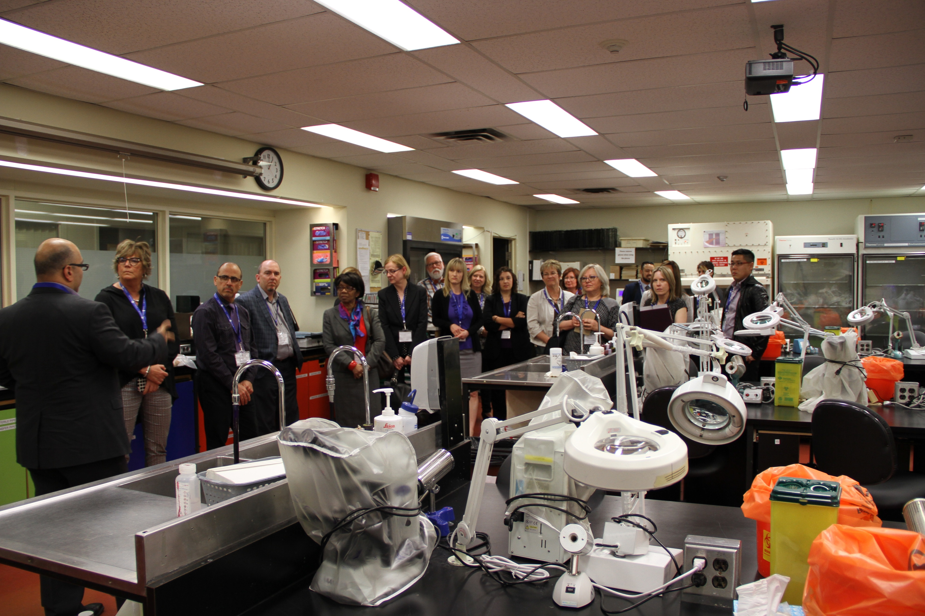

Forum Event Date: Saturday April 29th, 2017
Toronto, Ontario
Co-Hosted: Canadian Society for Medical Laboratory Science
and The Michener Institute for Education at UHN

Table of Contents
Executive Summary 3
Simulation and Clinical Placement – Employer Forum 5
Background 5
Event Purpose 7
Participants 7
Forum Structure and Discussion 7
Forum Summary 8
Knowledge Transfer Morning 8
Simulation Primer and Activity – Dr. Timothy Willett, SIM-one President and CEO 8
Simulation & Clinical Placement National Initiative – Laura Zychla, CSMLS Researcher, Forum Co-Chair 9
Perspective of the Student – Judy Tran, MLT Student and CSMLS Research Volunteer 9
Exploring the Employer’s Perspective - Christine Bruce, Administrative Director, Pathology & Laboratory Medicine, Grand River Hospital 10
Exploring the Educator’s Perspective – Dr. Peter Bridge, Chair, Medical Laboratory Sciences, Michener Institute for Education at UHN 10
Future State of Clinical Placement and Simulation Models - Dr. Brian Hodges, Executive Vice President Education, Michener Institute for Education at UHN 11
Knowledge and Solution Generation Afternoon 11
Small Group Discussions 12
Employer and Educator Panel 22
Conclusion 27
Appendix A – Summary of the Project Phases 28

Simulation and Clinical Placement – Employer Forum

Executive Summary
“There’s [health workforce supply and diminishing clinical placement] discussions in all kinds of circles, all kinds of profession, that I have heard about or been a part of. The only profession having this discussion explicitly, acknowledging the elephant in the room and deciding that at a national level to include all stakeholders – regulatory bodies, employers, educators –
is medical laboratory science.”

DR. TIMOTHY WILLETT – SIM-ONE PRESENT AND CEO

Workforce shortages combined with fast-paced technological change and restrictive health care budgets have changed the speed of knowledge adoption between academic programs and clinical laboratories. It has been documented that the divide between knowledge and practical application can effect competence and decrease a student’s ability to become a novice entry-level professional. Although medical laboratory science programs are meeting their program accreditation needs and therefore, requirements to produce competent graduates, there are concerns associated with the quality of clinical placement experiences and lack of placement site options (e.g., lack of dedicated preceptor time, lack of training resources to meet competency exposure in a clinical setting).

Academic programs are required to procure a clinical placement site and training spot for each student prior to entering into an academic program. Given the highlighted challenges, amongst others, the current scenario acts as a bottleneck in the student-to-professional pathway, ultimately decreasing our ability to increase the size of the medical laboratory workforce. In order to the change this scenario, new models of education and clinical placement training are required, in which simulation can play an important role.
The Canadian Society for Medical Laboratory Science (CSMLS) acknowledges the importance of innovative learning environments and hands-on practice through clinical placement experiences to ensure the next generation’s expertise in medical laboratory science. CSMLS is conducting a long-term initiative to examine models of simulation and clinical placements to enhance student learning, remove the burden from the clinical placement setting and engage educators in different academic techniques to accommodate the need. This initiative supports academic programs, health care organizations and the future medical laboratory workforce through understanding current system gaps that inhibit the increase of working medical laboratory professionals as well as creating evidence that supports other potential solutions.

In alignment with the conclusions drawn during Phase 1 of the initiative, CSMLS conducted Phase 2b – a national Employer’s Forum (April 29th, 2017 in Toronto, ON; co-hosted with The Michener Institute of Education at UHN). The event brought together private and public health care organizations and representatives, who support student learning in clinical environments, to continue the educator’s conversation from Phase 1.
In general, the purpose of the 2017 Forum was to bring together medical laboratory employer stakeholders and share key stakeholder perspectives (educators, clinical preceptors, recent graduates, etc.) that demonstrate the need for new simulation and clinical placements models to contribute to decreasing the impact of health human resource shortages. As occurred during the Educator Forum in 2016, all discussions and information were clearly focused on ways to improve students’ experience within clinical placements and didactic settings and support change to increase student seats in programs. Considerations for how simulation could support clinical placement models were highlighted throughout the event.
Approximately 60 participants were in attendance for the Forum and represented a diverse group of employers from across Canada, including those from rural and remote areas, urban cores, small to large labs, private and public labs, as well as representation from Medical Laboratory Technologist (MLT) and Medical Laboratory Assistant/Technician (MLA) professions. Attendees held a wide range of titles, as intended by the Forum, to ensure that professionals, clinical preceptors/instructors, management and senior executives were present. In addition, representatives included program instructors, regulators, government, medical laboratory professionals, simulation and curricula experts, CSMLS Board of Directors and staff members, and students.
The Forum was designed to provide information sharing in the morning and interactive discussion sessions in the afternoon. The morning highlighted information from an environmental scan of academic programs models on simulation and clinical placements, recent graduates’ clinical placement perspective, two employer surveys and other relevant research (reports can be found on the CSMLS website under Research). The afternoon sessions generated a vast amount of discussion and provided clarity around needs and solutions as perceived by employers. The small group session was used to describe the lived experience of the clinical preceptor and students in today’s clinical placement scenarios, identify the changes that need to occur at four levels of stakeholders and begin brainstorming on solutions to achieve this change. For this panel, three academic and three employer representatives were gathered to discuss their perceptions in regards to the future of clinical placement models, the type of changes that were coming in the future which may impact this, the value they placed in simulation to help transform such models to increase workforce and the requirements needed to achieve this. The panelists were chosen because of this variety in work experience, geographical diversity and exposure to simulation, allowing for a multiplicity of opinions to be explored.
The Forum was an excellent opportunity to start conversations with employers that built upon the information previously obtained from graduates and academic programs on simulation and clinical placement models in Canada. As noted during the event, the Forum represented a key entry point for employer stakeholders at all levels to grasp and start activating ideas that will support the profession locally, provincially and nationally. Overall, attendees represented a group of employers willing to engage, embracing academic programs in change as they recognize their connected threads which shape the fabric of the student experience and future professional workforce. Potential to foster this relationship and support new models of education and training were welcomed, focusing on the validity of simulation to act as a support mechanism in through competency acquisition and student throughput to increase the workforce. Additional solutions focused on restricting and/or dedicated funding models, creating greater consistency in training for students and preceptors, increased quality of supervision models and greater exposure to simulation. Recommendations for continuing the simulation and clinical placement discussion as well as supporting research to create evidence-based simulation curricula were positive outcomes of the event, reflecting the positive direction of the larger initiative to move forward.

Simulation and Clinical Placement – Employer Forum

Background
Canada is facing a serious human health resource (HHR) shortage with the MLP (includes Medical Laboratory Technologists [MLTs] and Medical Laboratory Assistants/Technicians [MLAs]). In 2010 the Canadian Institute for Health Information (CIHI) identified that approximately half of all MLTs would be eligible to retire in 10 years, with the greatest impact felt in Canada’s rural and remote communities. This period of time has closed in on the professional community across all provinces and territories resulting in a decrease of workers that dramatically impacts organizations and employees. Recently released data shows that the greatest loss within the MLT workforce (2010–2014) was associated with those who are 21 to 30 years post-graduation. Unfortunately, there was not a corresponding increase in the number of MLTs obtaining certification in any age category. In addition to staffing shortages, workload measures and workload complexity continues to show an upward trend for the profession. For example, Ontario had projected a 1.8% per year increase for lab tests between 2005 and 2010, however, an actual increase of almost 4% per year was experienced resulting in the number of tests going up faster than workforce capacity. The sheer number of new diagnostics and tests is exponentially growing. As an example, the National Institutes of Health Genetic Test Registry has more than 7,000 orderable tests for approximately 3,000 conditions and 6,300 genes, which represents a doubling of genetic tests over two years. Keeping up with the latest advances in testing, precision medicine, point of care testing (POCT) devices and diagnostic technology is not a small task. This means that students, professionals and academic programs must continually acquire large quantities of new knowledge to effectively deal with more complex equipment and situations.
It has been documented that the divide between knowledge and practical application can effect competence and decrease a student’s ability to become a novice entry-level professional. Although medical laboratory science programs are meeting their program accreditation needs and therefore, requirements to produce competent graduates, there are concerns associated with the quality of clinical placement experiences and lack of placement site options. As cited by Michau et al. (2009), “The scarcity of clinical placements limits training opportunities for students to work with real life patients, is undisputed as an invaluable learning experience. Placement shortages have derived from limited funding for training, staff shortages, patient availability, competition for placements between health care disciplines and an increasing number of students. In addition, this is further compounded with a pressured health care system that cannot adequately support student placements and the theory-practice gap has become an evident paradigm.”
Academic programs are required to procure a clinical placement site and spot for each student prior to entrance in the academic program. Given the highlighted challenges, the current scenario acts a bottleneck in the student to workforce pathway, ultimately decreasing our profession’s ability to increase the size of the medical laboratory workforce. In order to the change this scenario, new models of education and health care are required in which simulation may play an important role.
The Canadian Society for Medical Laboratory Science (CSMLS) acknowledges the importance of innovative learning environments and hands on practice through clinical placement experiences to ensure the next generation’s expertise in medical laboratory science. CSMLS is conducting a long-term initiative to examine models of simulation and clinical placements to enhance student learning, remove the burden from the clinical placement setting and engage educators in different academic techniques to accommodate the need. This initiative supports academic programs, health care organizations and the future medical laboratory workforce through understanding current system gaps that inhibit the increase of working medical laboratory professionals as well as creating evidence that supports other potential solutions. Table 1 highlights the project phases to date and provides access to relevant reports. Appendix A provides a high-level summary of the activities.
Table 1: CSMLS Simulation and Clinical Placement Initiative Overview
___________________________________________________________________________________________________________________________________________________________________________________________
Project Phase | Description
Phase 1a  Education | Information Gathering: Environmental scan of academic program models and survey of recent graduate’s experience during clinical placement
Phase 1b Education | Knowledge Transfer and Discussion: Educators Forum
Phase 2a  Collaboration &  Employers | Collaboration: Simulation Knowledge Exchange - Research Network (RE)  Evidence Creation: RE is creating short-term QA and research projects  Knowledge Transfer: Simulation and Clinical Placement National Discussion – Teleconference Series  Information Gathering: Survey of employer perceptions
Phase 2b Employers | Knowledge Transfer and Discussion: Employer Forum (current report)
Phase 3a  Collaboration | Evidence Creation: Large scale long-term research examining simulation vs traditional curriculum and effectiveness of simulation by amount, known as the National Medical Laboratory Simulation Study (funding application submitted)
Phase 3b  Collaboration | Knowledge Transfer and Discussion: To be determined

Event Purpose
“There’s [health workforce supply and diminishing clinical placement] discussions in all kinds of circles, all kinds of profession, that I have heard about or been a part of. The only profession having this discussion explicitly, acknowledging the elephant in the room and deciding that at a national level to include all stakeholders – regulatory bodies, employers, educators –
is medical laboratory science.”

DR. TIMOTHY WILLETT – SIM-ONE PRESENT AND CEO

In alignment with the conclusions drawn during Phase 1 of the initiative, CSMLS conducted Phase 2b – a national Employer’s Forum (April 29th, 2017 in Toronto, ON; co-hosted with The Michener Institute of Education at UHN). The event brought together private and public health care organizations and representatives, who support student learning in clinical environments, to continue the educator’s conversation.
In general, the purpose of the 2017 Forum was able to bring together medical laboratory employer stakeholders and share key stakeholder perspectives (educators, clinical preceptors, recent graduates, etc.) that demonstrate the need for new simulation and clinical placements models to contribute to decreasing the impact of health human resource shortages. As at the Educator Forum in 2016, all discussions and information were clearly focused on ways to improve students’ experience within clinical placements and support a change to increase student seats in programs. Considerations for how simulation could support clinical placement models was highlighted throughout the event.

Participants
For purposes of this report, employers are defined as managers, supervisors, clinical instructors/preceptors, organization representatives and medical laboratory professions who work directly or indirectly with students.
Approximately 60 participants were in attendance for the Forum and represented a diverse group of employers from across Canada, including those from rural and remote areas, urban cores, small to large labs, private and public labs, as well as representation from MLT and MLA professions. Attendees held a wide range of titles, as intended by the Forum, to ensure that professionals, clinical preceptors/instructors, management and senior executives were present. In addition, representatives included program instructors, regulators, government, medical laboratory professionals (MLPs), simulation and curricula experts, CSMLS representatives and students.

Forum Structure and Discussion
The Forum was designed to provide information sharing during the morning and interactive discussion sessions in the afternoon. Information highlighting the environmental scan report, recent graduates’ clinical placement perspective report, employer survey, relevant research and simulation information were provided. The event focused on key stakeholders: educators, students, employers and those training students within the clinical placement setting.
As outlined in the agenda below, the Forum was organized to prompt innovative ways of thinking and to provide an opportunity for discussing the current and future states of medical laboratory clinical placement and simulation models within Canada.
Three note takers (arms-length CSMLS staff and volunteers) were asked to circulate and capture discussion themes, comments and the perspective of audience members during each of the key discussion periods. This methodology provided an opportunity for objective interpretation and allowed for the capture of detailed information within discussions.
During the small group breakout session in the afternoon, participants were randomly divided and assigned a lead facilitator. Notes were captured with the small group participants on chart paper and are summarized in this report.

Forum Summary

Knowledge Transfer Morning
The following is a brief summary of the perspectives provided during each presentation and includes the PowerPoint slides shown to the audience.

Simulation Primer and Activity – Dr. Timothy Willett, SIM-one President and CEO
A number of Forum employer participants indicated in their registration process that they were not deeply familiar with simulation as an education technique due to a lack of exposure or theoretical understanding. Dr. Timothy Willett effortlessly introduced simulation to the audience and delved into some of the major research that supports the use of simulation in the academic and continuing education settings, including information that supports the use of simulation to enhance clinical placement.
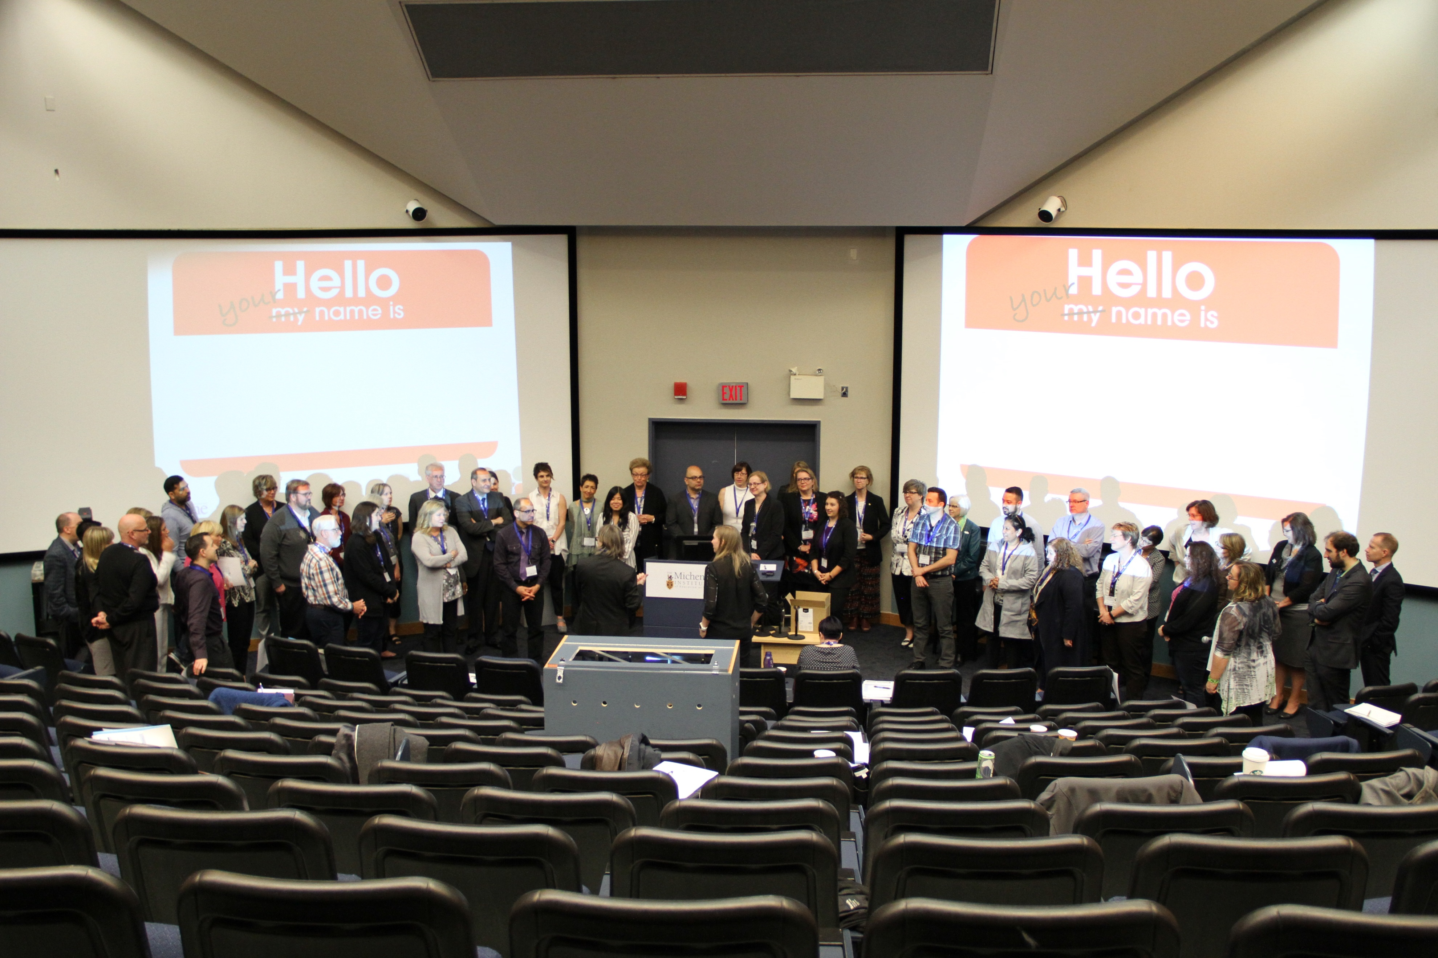

Forum attendees participating in a simulation exercise led by Dr. Timothy Willett

Simulation & Clinical Placement National Initiative – Laura Zychla, CSMLS Researcher, Forum Co-Chair
As Co-Chair of the event, Laura Zychla provided a high-level understanding of the CSMLS project to date including highlights of the research completed as well as summarized the importance of the results and impact that the simulation and clinical placement movement had already begun with academic programs. Laura recognized the importance employers, educators and students play within the initiative as well as the potentially vulnerable position that students and clinical preceptors are in given their respective roles. Acknowledgment for the work that all stakeholders play within the clinical placement model is pivotal and remains at the forefront of information seeking and solution building activities.

Perspective of the Student – Judy Tran, MLT Student and CSMLS Research Volunteer
At the Educator Forum in 2016, a panel of recent medical laboratory science graduates who had passed the CSMLS certification exam was convened to discuss the findings of a CSMLS survey and provide their perspective of the student experience during clinical placements. At the Employer Forum, Judy Tran, a current MLT student provided information on these previous datasets as well as highlighted the important role employers play in the student experience. She discussed the ability of her simulation experience to enhance her training within clinical placement.

Exploring the Employer’s Perspective - Christine Bruce, Administrative Director, Pathology & Laboratory Medicine, Grand River Hospital
As part of her degree requirements, Christine Bruce worked with CSMLS to conduct a survey and examine the employer’s perspective of recent graduates within the workplace. Among other concepts, the results of the study showcased the quality of service provided in the lab as well as areas where clinical placements could change to increase efficiencies in student training and employer resources. Christine also provided introductory results for the Employer Simulation and Clinical Placement Employer Survey that was conducted by CSMLS as an extension of her work. Note that the results in these slides represent preliminary data and all results should be referenced from the final report located on the CSMLS website (research section).

Exploring the Educator’s Perspective – Dr. Peter Bridge, Chair, Medical Laboratory Sciences, Michener Institute for Education at UHN
Many CSMLS members have asked for evidence from medical laboratory science programs to show that simulation can decrease the number of clinical placement hours without resulting in unnecessary hardship for students and academic programs. Dr. Peter Bridge provided such evidence from the Michener experience as well as additional considerations when changing clinical placement models to support student throughput (buddy system) and increased student experience (safety initiative).
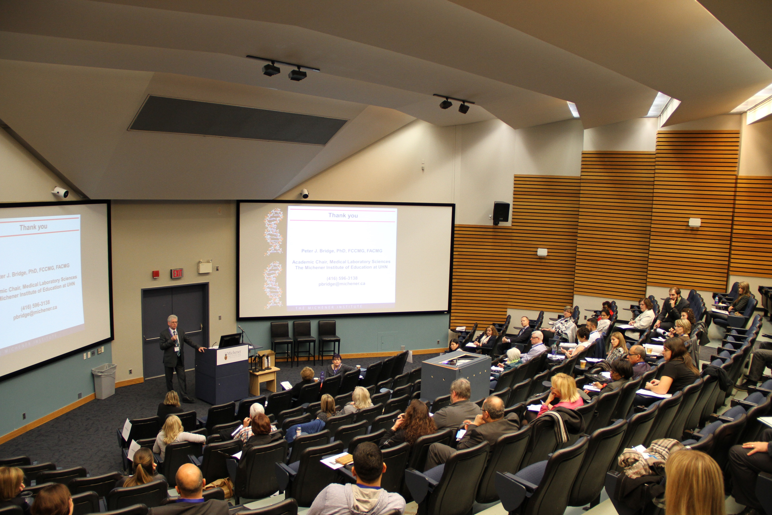
A snapshot of Dr. Peter Bridge’s presentation in which he showed evidence that simulation can replace a large number of clinical hours without effecting CSMLS certification examination pass rates, as demonstrated by Michener students.

Future State of Clinical Placement and Simulation Models - Dr. Brian Hodges, Executive Vice President Education, Michener Institute for Education at UHN
After the stakeholder perspective presentations, it was necessary to start thinking beyond the current state and look at what may impact our profession’s future and the students that will be a part of that future. In his charismatic and thought-provoking manner, Dr. Brian Hodges shifted the audience thinking to understand how concepts such as cognitive load theory and the practice of other professions using simulation have a direct relationship with to what the medical laboratory community is trying to achieve through the Simulation and Clinical Placement initiative. In addition, Dr. Hodges was able to provide practical examples of forward-thinking for our community and how to enhance learning for students within the clinical environment.

Knowledge and Solution Generation Afternoon
The afternoon sessions generated a vast amount of discussion and provided clarity around needs and offered solutions as perceived by employers. The small group session was used to describe the lived experience of the clinical preceptor and students in today’s clinical placement scenarios, identify the changes that need to occur at four levels of stakeholders and begin brainstorming solutions to achieve this change.

Small Group Discussions
“I think the issue of [clinical] placement is on the mind of every placement coordinator and every education institution. It’s nice to hear the cooperative and professional discussion because it’s on our minds – the way we have to fill the gaps for placement sites and the experience of students.”

Kamil Haddad – Program Dean, Medical Laboratory Technician at Medic College
Each facilitator was provided with the small group discussion questions, the ability to record participant answers. This report section provides a summary of the results as recorded by the facilitators and participants. A total of five breakout rooms were provided. Attendees were randomly assigned a breakout session, providing an opportunity for a diverse group of representatives to be in each discussion. The following questions were asked within each group, time permitting:
- What is the lived-experience of a clinical preceptor while training students? How do students react to clinical preceptors? Let’s take a few minutes to describe what we perceive students and preceptors, and their reactions based on what we know about ourselves and the experience of others.

We know that the range of feelings and reactions is wide for both groups. We have heard from students that most of their experience in the clinical setting is great, but when a bad day occurs it leaves a lasting impression. We want to understand what creates a positive learning environment and how to decrease the impact of negative moments.

See Table 2 on the following page for a summary of the reports. The purpose of this activity was to enable all participants to understand the stressors of clinical preceptors and students under the current health system restraints (e.g, workforce shortages, lack of dedicated time for training) as well as the emotional and behavioural reactions that can occur as a direct result. By understanding and relating to their lived experience, not only does the group contribute to validating the impact of system issues on the populations but also obtains a greater appreciation for matters at hand. Verbal feedback from the CSMLS facilitators acknowledged the value participants felt in supporting clinical preceptors (for themselves, students and organizations) to achieve ‘good days’ as often as possible.
In general, Table 2 demonstrates an obvious but important conclusion/reminder – clinical preceptors and student can have a parasitic or symbiotic relationship. The more negative the work environment, the worse the relationship can be. Given that both populations are in potentially vulnerable situations (e.g., students may not speak up as they want to pass their practicum, clinical preceptors may not speak up as they don’t want to be perceived as not doing their job well), it is important to recognize this concept and look for opportunities where a positive outcome can occur.

Table 2: Lived experience of clinical preceptors and students as described by Forum attendees
Laboratory Role | Type of day person is having | Description / Feelings | Reactions
Clinical Preceptor | Good Day | Students are excited to be in clinical, not rushed/stressed, pride in knowledge, challenged (leads to improvements), accomplished, contributing to the future, assisted – helped with work, appreciated, part of a team, prepared, motivated, happy to share knowledge, empowered | Making a difference, receptive, willing to help, welcoming, treats students with respect, motivated to do more, challenging students appropriately, spending more quality time, willing to teach again, share more/be more open, conversing, providing more constructive feedback, responsive, facilitating, going the extra mile, listening
 | Bad Day | Overwhelmed, angry, alone, overworked, frustrated, stressed, tired, anxious, failure, stupid/disappointed in self, ethically challenged, unsupported, frustrated, burdened, rushed, less patience, undervalued | Increased possibilities of error, ‘short’ with student, inattentive, off-putting, menial and simple job assignment, rushed, no feedback, no quality time, resentment, ignoring, avoiding, suboptimal training
Student | Good Day | Valued, welcomed, prepared, safe (technical and HR), engaged, challenged, excited, successful, have a role (plan/structure/goals), eager, motivated, nervous (right amount), confident, supported, confident in profession choice, happy, empowered | Good communication, comfortable communicating, able to ask questions, motivated to learn, more intuitive, meaningful contribution, participate in a team, easy to learn, networking
 | Bad Day | Stressed, alone, neglected, an inconvenience, stupid, dangerous, dealing with work politics, ethically challenged, nervous, frustrated, disappointed, want to go home, cheated, angry, scared, targeted, isolated, nuisance, useless, uncertain | Avoidance, won’t ask questions, lack of attention, no initiative, ignoring work and people, not living up to appropriate expectations, unprofessional

- We have heard today that there is evidence to support the use of simulation in the education of health science students and it has the potential to reduce clinical hours. In many medical laboratory academic programs in Canada, educators are incorporating more simulation into their curricula. From the employer survey conducted by CSMLS and Christine Bruce, we also heard that some competencies are difficult to teach and sign off on in the clinical placement setting. Simulation may support health care organizations by training students in such competencies prior to their clinical placement.
If we could change our clinical placement models, in an ideal world what would this look like? You will see 4 pieces of paper around the room. Each of you can get up and take a few minutes to write down the type of changes you want to see in each of these buckets.
There are no wrong answers as we are thinking about an ideal world. The change might be at a local, provincial or national level. The idea might also be a short-term or long-term goal.

This brainstorming activity was intended to generate ideas that are within and outside traditional concepts for change. As there is an evolution occurring for the medical laboratory profession, driven by external factors, consideration for non-traditional ideas is defendable. The following is a summary of ideas presented and should be used to extrapolate concepts locally, regionally, provincially as well as for national consideration. Not all ideas will apply to everyone, and therefore should be considered in relation to the reader’s needs. Our professionals encapsulated a wide degree of variability in that regard and the suggestions reflect this.
Note that the groups per category are based on the interpretation of notes made by facilitators and attendees. It is possible that some of the results may have been misinterpreted if the content was not obvious. However, facilitators were contacted when questions arose and the report writer was present for the dissemination of the small group discussion with the entire audience at the event. Therefore, considering similar themes have arisen with each group and these other concepts, it is likely that the majority were interpreted correctly.

Creating Positive Change for Clinical Placement Sites - Organizations
- Creating consistency
  - Create centralized clinical placements
  - Standardized practicum mandate or recommendations from CSMLS – too many clinical placement variations

- Funding considerations
  - Standard funds and allotments for clinical placements
  - Vendors could fund students
  - Hospitals should submit budget to departments of health to fund clinical placements
  - Ensure that financial supports for clinical staff to support students while maintaining reduced lab duties
  - Funding would help to create dedicated trainers for sites
  - All clinical sites should have trained preceptors and budget for students

- Training opportunities
  - Retired MLTs as preceptors
  - Support for staff training in adult educations for preceptors
  - Should know how to give effective feedback
  - Create education sessions for staff – “A day in the life of a student”
  - Preceptors to be more trained to deal with mature/foreign trained students
  - Preceptor training
  - Allow for interprofessional education in clinical setting

- Resource requirements
  - Access to a laboratory information system for simulation training; needed prior to clinical placement
  - Have simulation rooms for students to practice in
  - Need trained simulationists
  - Provide feedback on knowledge gaps and common scenarios ideal for simulating
  - Communicate with educators to clarify what is needed/expected for new grads
  - Provide preceptor incentives i.e., education, paid etc.

- Dedicated Duties
  - Preceptors to have dedicated time associated with having students and not required to carry a full-clinical service workload as well
  - Designated preceptor-student focused placements
  - Increased opportunity to learn how to be preceptor - add to job competencies
  - Have a backup plan for when preceptor is sick or on vacation
  - Dedicated training personnel with employer incentives to teach (to support)
  - Clinical liaison position to facilitate prep of students to clinical – encompasses simulation and actual clinical bench work

- Shifting Culture
  - Relationships
    - Continue to build partnerships and support with institutions/universities and colleges
    - More collaboration between health authorities/labs to create more clinical placement sites
    - Encourage staff to participate in student training

  - Student-centred
    - Remember that students starting their clinical are still students and not entry-level techs
    - Be prepared for students (e.g., have an orientation and schedule)
    - Have some pre-planned student activities that can be used on crazy days when there is no time to teach
    - Culture shift in the institution – students are great thinkers
    - Time – students built into business model
    - Regular feedback to students

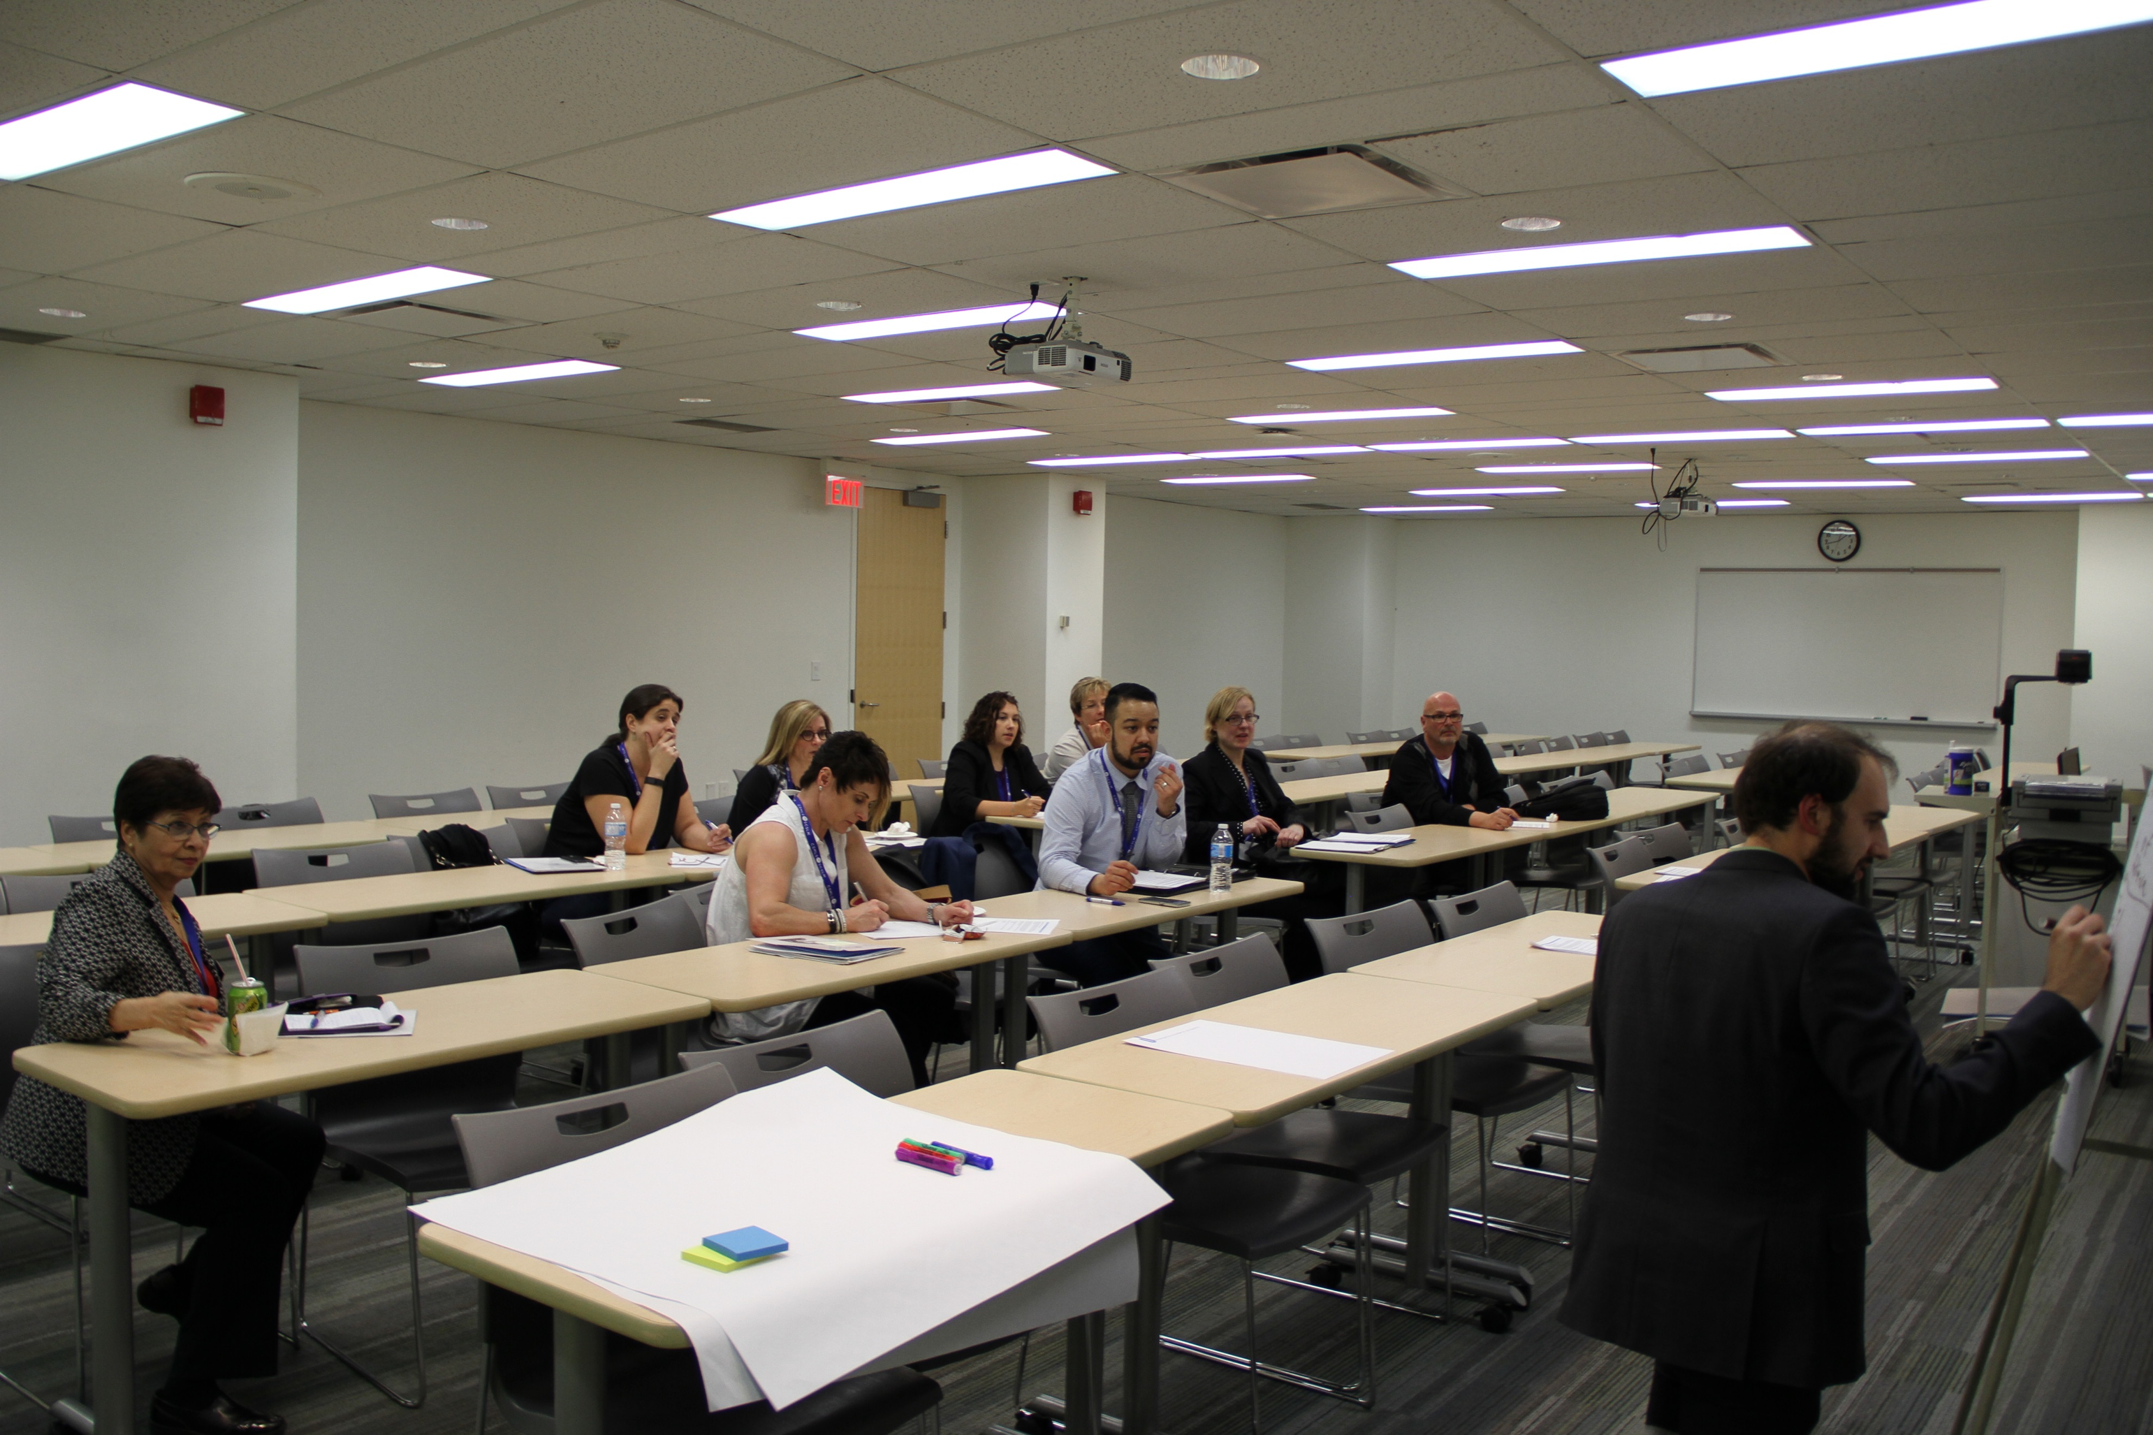 John Soltys leading a small group discussion session with Forum attendees.

Creating Positive Change for Academic Programs
- Curriculum
  - Culture change to embrace simulation and training on it
  - Embrace the use of simulation where logical
  - Find more ways to embrace clinical site staff participation in simulation
  - Explore removing time-based training to fully competency-based
  - Incorporating or introducing into 1st year program: Code of Ethics, intro to QA fundamentals, soft skills and to continue into 2nd year placement
  - Support competency-based education using multiple modalities and tech support
  - Collaboration between academic and clinical partners to share competencies between simulation and clinical
  - Increase simulation period followed by clinical placement
  - Create microbiology and histology simulation labs; also add cell identification and soft skills
  - More distance education options for rural areas
  - Increase simulation soft skills
  - Create curriculum for clinical
  - Change the program to reflect what is happening in ‘real’ life workplaces
  - Better transition from didactic to clinical especially soft skill abilities
  - Use LIS training simulations at the college level prior to clinical placement
  - Students do not have enough practice in technical skills when they first enter the clinical rotation – more practice needed

- Training
  - Training for simulation; ensuring simulation is administered properly
  - Centralization of certain tests – simulation activities held
  - Flexible academic schedules
  - Training for staff on simulation

- Maintenance of Clinical Knowledge
  - Educators to spend a week in clinical setting in discipline they teach per year
  - Industrial leave – yes, they should at least be keeping up-to-date on new processes and technology
  - Clinical instructors should be required to maintain working clinical experience
  - Maintain instructors with enough experience and current knowledge be effective
  - Mandatory workplace training and ensure training resources
  - Faculty should be a subject matter expert in the area of instruction
  - Those involved in simulation may need to have current knowledge
  - Clinical instructors need to have current practice knowledge
  - Part-time faculty/practicing technologists
  - Academic instructors need access to time in clinical placement labs to maintain and expand knowledge, skills and competencies

- Administration
  - Increase student selection criteria
  - Look at lengthening programs (if necessary)
  - Increase didactic time to allow students to really understand the materials. Right now students seem to study for tests and then it’s gone
  - Same length of time for clinical placements
  - Work with partners to determine simulation vs actual clinical experience
  - Collaboration between institutions
  - Having spots and agreements in place

Creating Positive Change for Students
- Student Advice
  - Understand role as a student; Learn in school how to do this - role play
  - Be their own advocate
  - Provide feedback and ask for feedback
  - Be more involved in their day-to-day clinical environment (understand tasks / communicate preceptor expectations at start of the day, how doing mid-day and recap how they feel at the end of the day
  - Create personal learning goal for each day
  - Progressively increasing autonomy
  - Use your voice rather than accept the obvious wrong. Students are building the future medical laboratory profession culture.
  - Punctual
  - Know they have a responsibility to learn; Not all the responsibly of the trainer
  - Be helpful – pitch in, show initiative
  - Don’t be demanding
  - Flexibility
  - Accountable for own actions and critical thinking on how to resolve (before or after clinical?) – demonstrate communication, improve professional interactions and demonstrate responsibility and application
  - Be respectful of everyone
  - Better prepared coming to clinical
  - Ask questions, be proactive, use the opportunity to learn as much s you can

- For organizations
  - Must be a physical space for students
  - Clear communication pathways for addressing concerns
  - A different way to address low performing students – an added means of coaching
  - Develop soft skills simulation
  - Learning plan in the institution
  - Make students more comfortable when assigned to clinical

- For academic programs
  - Students arrive with certain baseline skills
  - Knowledge gaps are real and simulation training would helpful
  - Yes – use simulation by preceptors in hospital/private lab; Can use the school clinical instructor to simulate
  - More simulation in soft skills and critical thinking, basic lab procedures
  - Provide simulation before clinical. Have students assessed during this time. Clinical placement could be a checklist and support
  - Students to be aware of work culture and work expectations ie, be prepared, no cell phones, active listening.
  - Be theory ready
  - More simulation; less depending on the institutional sector

- Other
  - Payment for students in the clinical setting
  - If we can expand the program structure to breakdown the group of 5 disciplines, more opportunities are possible for students
  - Time varies by discipline – someone needs more time in a discipline than another or with another skill

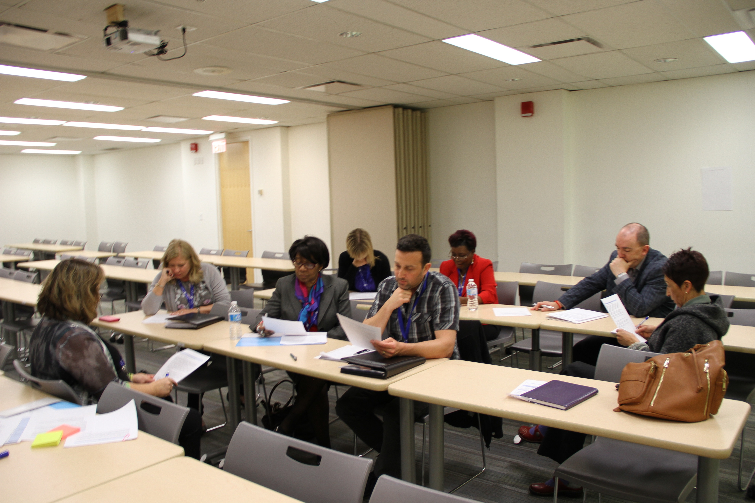

Lorna Zilic leading a small group discussion session with Forum attendees.

Creating Positive Change at the National Level

- Education
  - Recommendations for curriculum able to simulate
  - Proper guidelines regarding simulation for accreditors
  - National standardized MLS-simulationist training program
  - Provide more support/documentation to educational institutions
- Standardized length of education program
  - CSMLS to provide preceptor training so preceptors can have a standard point of reference
  - Structured improvements to high levels in the profession
- Training for clinical placement preceptors and training for clinical preceptors
- Provide tools for the clinical placements so that they have the right people training in
simulation

- Competency Profiles
  - National competency profile to include “mandatory” clinical practice requirements – using all stakeholders to develop and validate
  - Distinction between “care” and “extended” competencies e.g., in specialty areas Recognition of a masters program
  - Simulation competencies to be developed
  - Remove unnecessary activities from competency profile
  - More guidance on the breadth and depth of technical competencies for MLT and MLA
  - Recognition that a national competency profile is difficult as an entry to practice MLP differ across country
  - Have CAMLE work with CSMLS to create guidelines for minimum competency so not over preparing students (standardized entry-level graduate)
  - New Competency Profiles
    - CSMLS needs to explore the options for designations (i.e., MLT -core, MLT – Micro, MLT – anatomic pathology /cytology etc.; similar to subject RTs)
    - Consider re-establishing subject certification options for MLT; fast track options
    - Consider certification categories (CXLT?) for rural sites
    - Subject MLTs in larger labs
    - General national competency profile for MLT; remove histology, cytology and electron microscopy into specific certifications

- Funding
  - Government funding for clinical placement of students to go to other sites for their training
  - Funding for clinical placement sites
  - Federal and provincial departments of advanced education provide practicum funding

- Complex Collaboration
  - Collaboration to develop universally needed simulations/simulators e.g., shared investment in computer-based simulation accessible to all
  - Facilitate and encourage collaboration between education institutions
  - National accreditors/regulatory bodies to acknowledge simulation as a learning experience
  - Student clinical placement can be anywhere in Canada (bank of clinical spots)
  - Require membership with CSMLS to strengthen society overall

- In the last question, we discussed the change we need to see from different stakeholder groups to achieve an ideal clinical placement model. Now let’s think about the solutions to make change happen.

How can we support our academic programs and laboratory departments to increase safety practices as well as use time efficiently when training students in the clinical setting? How can we support clinical preceptors during this time of fiscal constraints, human health resource shortages, and increased stress/burnout?

As you think about solutions to support change, also consider trends that will impact the medical laboratory profession and laboratories in the next 5 to 10 years? What should we be preparing students and professionals for, and how can simulation help?

There are no wrong answers. Create a table with three columns: Solution, Ease of Implementation, and Goal Timeline.

The range of potential solutions is wide, suggesting that there are multiple complex avenues that need to be examined to activate the steps to a final proposed outcome. What is clear from the results is that a new funding model for clinical placement sites, a more standardized training model for clinical preceptors and greater guidance documentation for clinical sites are required.

Where information for ease of implementation and goal timelines were left bank on small group discussion recorded sheets, the author of this report as added in information based on knowledge of the Forum event and related discussions.

Table 3: Potential Resolution Contributors to Innovate Clinical Placement Models
Potential Solutions | Ease of Implementation | Goal Timeline
Greater regulation around what to test | Hard | Long term
Increase funding / new funding models (dedicated funds for students and preceptors) | Hard | Long term
Increase student and preceptor retention | Easy (if new funding model) | Short – Long term
Patient funded testing | Hard | Long term
National preceptor training | Hard | Medium – long term
Increased automation | Hard | Short – Long term depending on the program
National student benchmarks | Hard | Medium term
Standard clinical practicum length | Hard | Long term
Centralized clinical placement model | Hard | Long term
Standard funds for clinical placements | Somewhat difficult | Medium term
Vendors funding students | Hard | Long term
Retired MLTs as preceptors | Somewhat difficult (licensing) | Medium term
Time-to-competency evaluation | Easy | Short term
Student-focused assignment of practicum | Easy | Short term
Standard practicum document | Easy | Short term
Standard length of academic programs | Hard | Long term
Simulation period close in time to clinical practice (make the students responsible) | Somewhat difficult | Short term
Teach students to communicate assertively (simulation?) | Easy | Short term
Understand difference between good and bad behavior as a student (soft skills) | Easy | Short term

Employer and Educator Panel

For this panel, three academic and three employer representatives were gathered to discuss their perspectives in regards to the future of clinical placement models, the type of changes that are coming in the future which may impact this, the value they placed in simulation to help transform such models to increase workforce and the requirements needed to achieve this. The panelists were chosen because of the variety in work experience, geographical diversity and exposure to simulation, allowing for multiple opinions to be explored. The panel included:
- Norma Page, Vice President, Clinical Operations at DynaLIFE Medical Labs
- Julien Pho, Learning and Development Specialist, Department of Quality and Regulatory Affairs, and student Clinical Coordinator for LifeLabs
- David Moore, Director, Upper River Valley Health Zone of Horizon Health Network
- Jim Tsourgiannis, Laboratory Services Manager, guest lecturer and Continuing Education Instructor at the Michener Institute of Education at UHN
- William (Bill) Younger, retired Chair of Allied Health Sciences and current consultant for Red River College
- Lisa Purdy, Associate Professor in Laboratory Medicine & Pathology at the University of Alberta and Director of the BSc in Medical Laboratory Science program
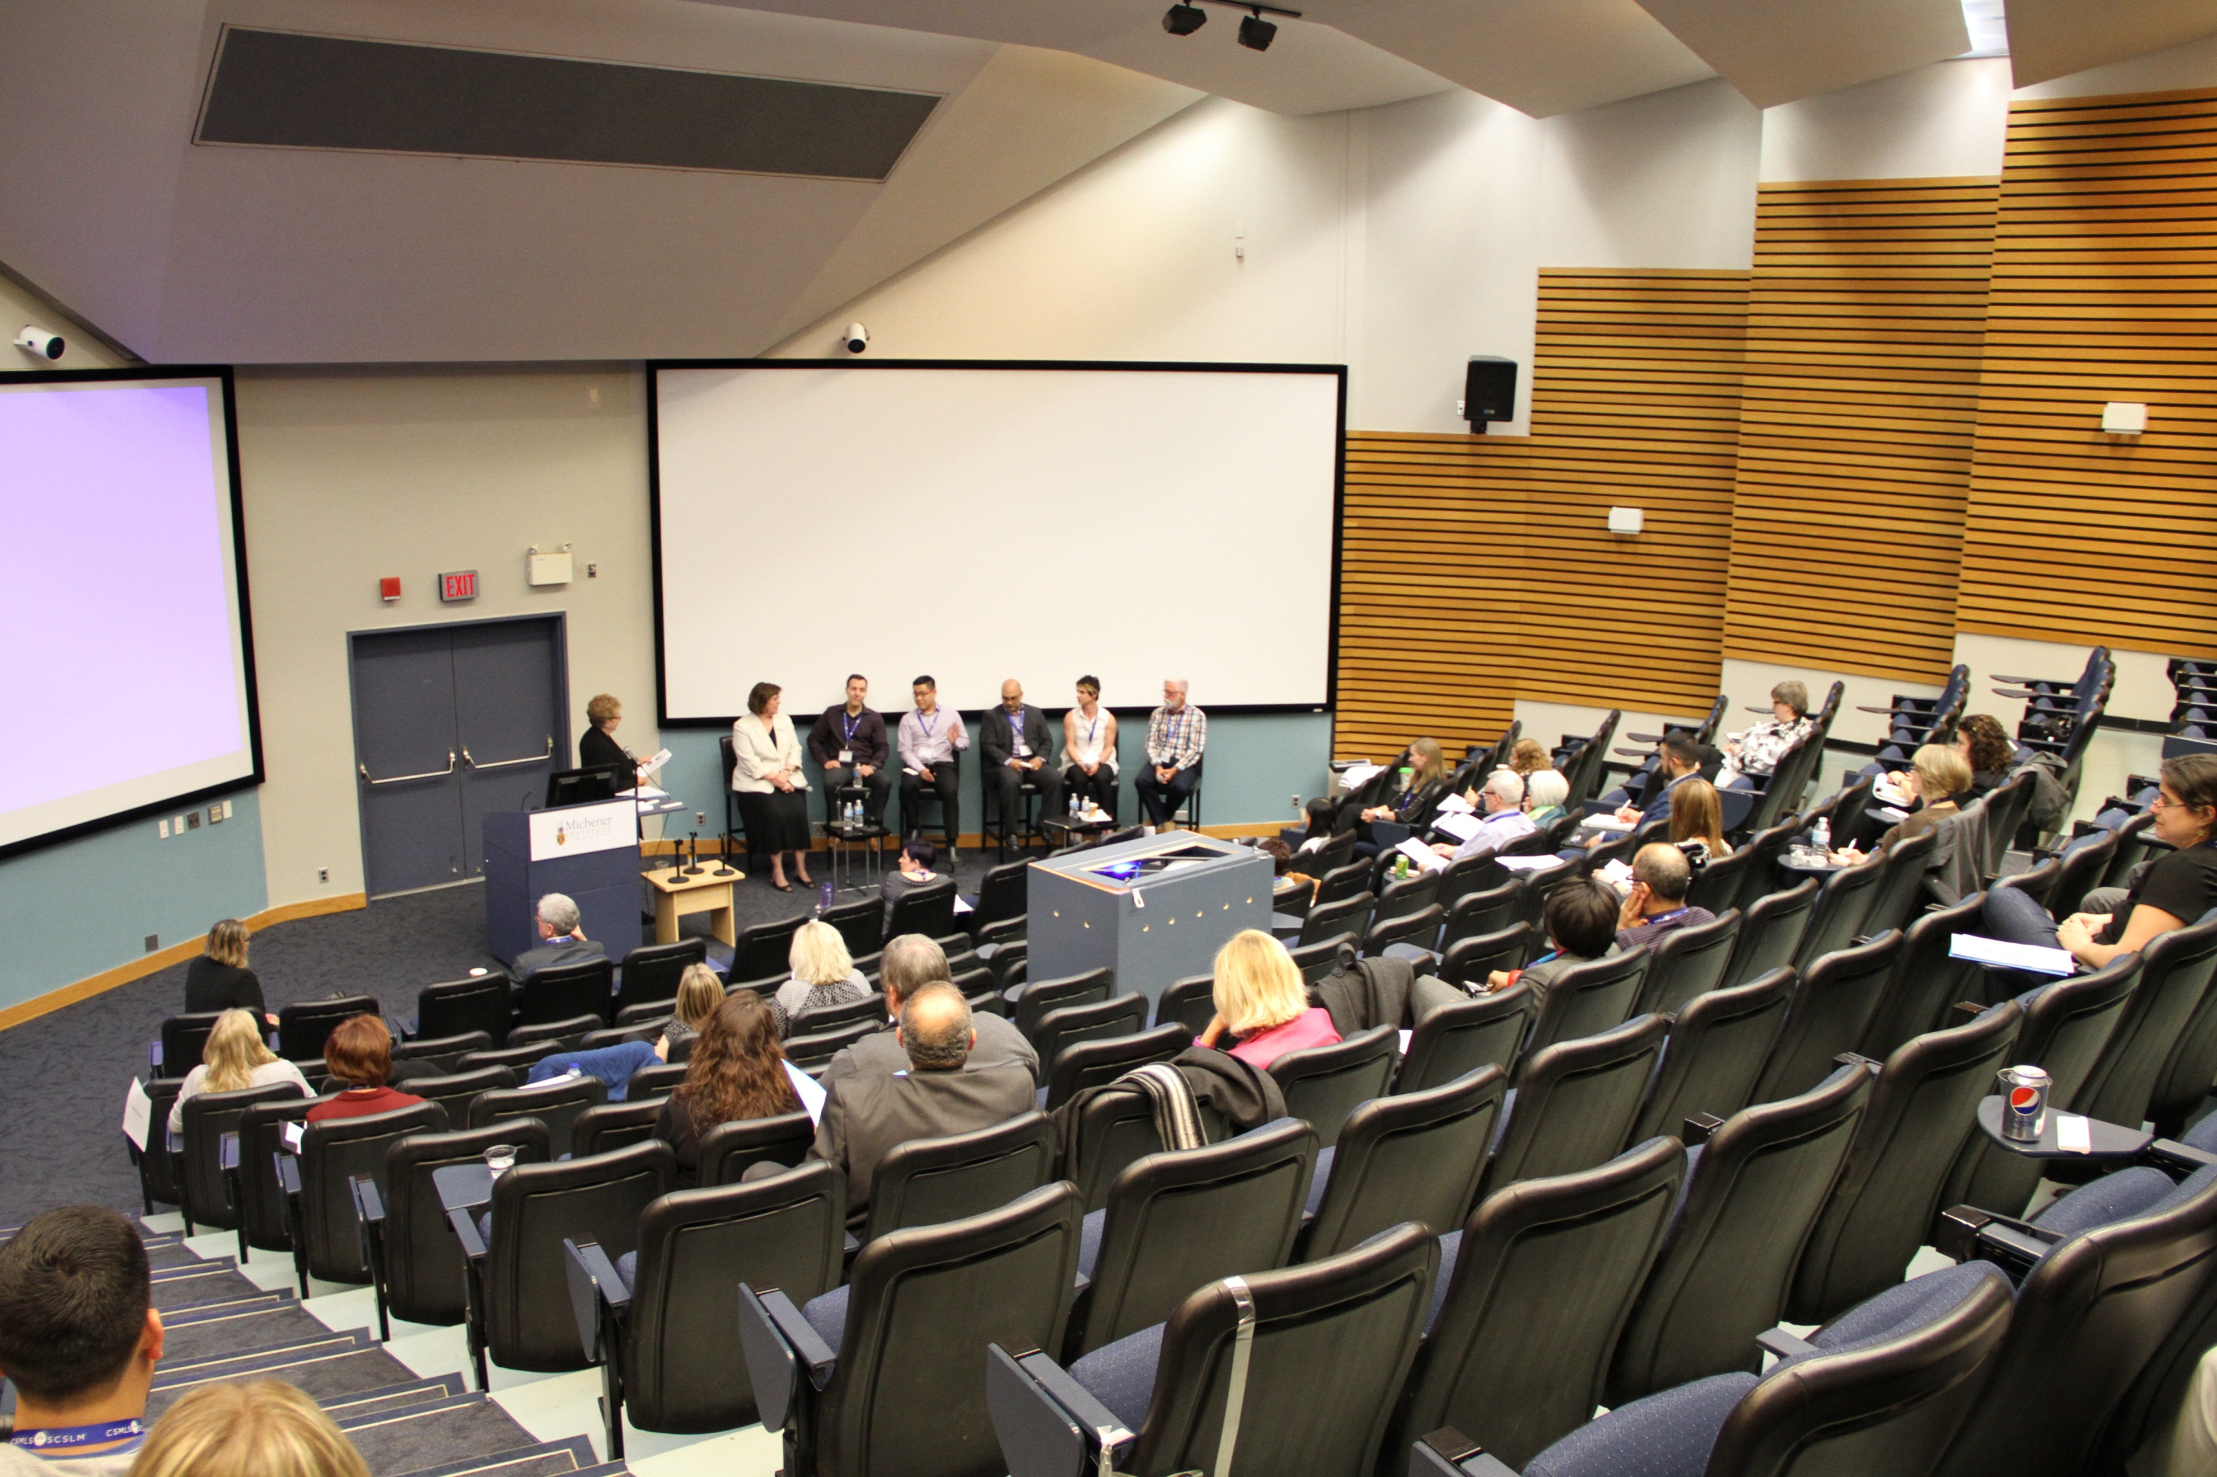
Rae Gropper facilitating the panel discussion which included audience participation.

Panelist questions were derived prior to the event but modified based on the content from the small group discussions and general audience comments to ensure extrapolation of ideas populated throughout the day. The following questions in blue are noted for a general reference to those that were asked at the time of the panel.
From the survey results discussed this morning, we can see (for the most part) that programs are obtaining clinical placement spots for their students. However, there were comments that indicate it can be difficult sometimes to obtain the spots and that there is a desire to ensure the quality of those placements goes beyond satisfactory.
Knowing that clinical placement sites represent a bottleneck for getting students into the workforce faster, and thinking about the solutions we heard from our small group discussions, what are the most tangible ways to reduce clinical hours or increase the number of students you receive in the clinical setting over the next 2 -3 years?
Panelists were keen to discuss the concept of increasing communication to build stronger relationships between educators and employers, given that this is the key concept for change management. For example, to increase simulation use within academic programs the community needs to share their knowledge and experience with one another to support efficient use of resources during times of fiscal constraint. Also, there needs to be direct discussion around the needs of local clinical sites about the topics that are not required to be taught fully within the clinical environment. It was not perceived that a national standard could be created on what this should or should not include due to the flexible models that have been built around accreditation for competencies; however, guidance documents and information sharing are important. Discussions on how to measure what should replace clinical hours and how much this ratio represent were considered a gap in information that would be useful (1 clinical placement hour: 1 simulation hour vs. 1 clinical placement hour: 0.5 simulation hour).
The concepts of student-centred clinical placement models were discussed in relation to Judy Tran’s presentation, highlighting the necessary movement towards incorporating more students within decision making and feedback models, as well as the concept of increasing the investment in student training as they become excellent hires (seamless transition from training to employee), potentially saving the system time and resources. For example, weekly feedback from students increases the likelihood that educators will be aware of issues before something gets out of hand or is passed over. The panelists recognized that the student experience as discussed in the Recent Graduate Survey and at the Educators Forum in 2016, is reflective of the current situation; albeit the information needs to continue to be disseminated to ensure that employers are aware of the degree to which this is occurring.
“To hear about how simulation is being approached in other areas is made me very optimist about what can be achieved, with very low cost in some areas. it does give me a better idea of what we can offer our students, either with partnership with other hospitals or other adjudication sites.”

Julien Pho - Learning and Development Specialist, Department of Quality and Regulatory Affairs, and student Clinical Coordinator for LifeLabs
A great respect for the work of clinical preceptors was prominent within all discussions. The panels recognized the workforce shortages, changes in workload, and lack of dedicated time clinical preceptors are given to work with students. The group discussed the concept of it being hard for clinical preceptors to make students comfortable within the clinical setting due to different personalities and training styles as well as difficulties around managing student expectations. The discussion furthered the note that there is a lack of consistency in clinical preceptor training and that some individuals are required to take on the position due to demand rather than desire. It was recommended that clinical preceptors who do not wish to be in the role can and should be removed from the duty, given the current state of our profession (i.e., burnout, staffing shortages, increased workload).
Panelist discussed the idea that there is a perception that a personalized clinical placement program for each student would bring the greatest benefit; however, it is unlikely that this is a viable option for most academic programs and clinical sites. Nonetheless, the importance of such models was noted and could be suggested for programs where this is possible (e.g., buddy system model as noted in Dr. Bridge’s presentation, personalized plans for struggling students, different lengths of clinical per discipline). That being said, the panel recognized that other models with some flexibility for students in need of additional training should be activated. Depending on the model structure, a reduction in clinical placement time was noted for some advanced students which may offset time provided to students requiring a more personalized approach.
To further probe the idea, the facilitator asked the panelists to directly, “Can we reduce clinical time?”
The responses were mainly dependent on the direct experience of the panelist. For example, those with shorter clinical placement times would prefer that the training isn’t decreased further or even in cases where training was long, the concept of “don’t mess with a good thing”, comes into play. There was also support for the general statement that clinical placement hours could be reduced for some programs across Canada and that simulation can support this. A general need for employers to better understand the evidence behind this statement and the demonstration of the effectiveness of simulation within medical laboratory science programs would be highly beneficial. Understanding what competencies training would be removed or have been removed by programs within the clinical environment was of interest to the panel. All educators agreed that it was possible to reduce hours. One panelist noted that Michener could likely continue to reduce its clinical hours and suggested that approximately half of the competencies could be removed from the training. Clinical placement hour examples:
- Ontario – 12 weeks could be reduced further with simulation
- British Columbia – 42 weeks decreasing to 36 weeks next year
- Alberta – 38 weeks currently
- Manitoba – 11 weeks reduced to 9 weeks for microbiology
“About doubling [program] capacity, I think there is a lot of opportunity if you have a longer program because it gives you flexibility. When you have a short program it does, I think, make it difficult to rearrange. That could be a challenge but I wouldn’t say it’s impossible. It just needs to be looked at.”

Tricia VanDenakker - Deputy Registrar, College of
Medical Laboratory Technologists of Manitoba
Another panelist recognized that there should be a distinction between minimal competence and ready-to-work as there is a divergence between what employers need (i.e., proficient workers after graduation) and what educators are required to produce (i.e., the competency requirements for accreditation). A student does not “work” within the clinical placement but, rather, is trained during this time – a good reminder of the student role and perception needed when examining clinical placement models.
The group discussed ideas on where simulation could support a decrease in clinical hours. It was noted that educators in general believe that much can be done with simulation in this regard as well as students often have down time in clinical placements where other skills could be worked on. Simulation was first discussed in reference to essential (soft) skills that need to be highlighted in for the clinical environment but can be prepared for within simulation activities.
To bring the audience into the conversation, the facilitator asked the attendees directly, “Can clinical placement hours be shortened? How do we know what the right number of weeks is?”
Audience comments reflect that of the panel – a mixture of reduction efforts dependent upon the local program and clinical setting needs are possible. The question of “proof” required to achieve this reduction was raised again as a valid point. A Michener representative further provided local project experience and discussed the evidence used to reduce their clinical hours prior to the creation of the large simulation centre housed at the college. It was reiterated, in general, that there is a lack of medical laboratory-specific evidence to demonstrate that such a reduction in hours was publicly available although programs have achieved reductions across time. This is an area for further investigation and dissemination by programs.
As a generalized statement for accredited programs, an individual noted that if a program can demonstrate students are passing didactic learning but failing their clinical placement settings, the number of clinical hours is likely not enough for the didactic needs to be modified by other techniques such as simulation. Other measures to determine the right number of weeks can follow the certification exam pass rates (as used by Michener), but ultimately metrics that track what the students are completing in training, how much time it takes, competency pass rates at specified intervals and a tracking of this information as programs change, can demonstrate that students are or are not impacted by changes in clinical hours.
The medical laboratory profession is changing in many ways. For urban large centres, technology, staff shortages, precision medicine, task shifting, access to larger budgets compared to rural centres etc. will facilitate this change over the next couple of years. For more rural or remote locations the change is going to be longer. How can academic programs support closing the theory to practice gap for students during clinical placements in the future? What does the future medical laboratory student and professional look like? Are academic programs ready for this change?
A clear consensus that there will be a dramatic increase in technology in coming years and this is highly likely to be one of the greatest impact on the medical laboratory profession. Due to this, technologists will likely be engaged in more engineering-like duties such as fixing computerized and mechanically diagnostic equipment. This will create a widening theory to practice gap between academic programs and clinical environments as educators are not currently able to keep up with the technology change as it is. To rectify this concept, a fundamental and systematic change would need to occur across all programs in funding models among other secondary and tertiary impacts. Consideration for competencies to match this evolution of the profession were noted and that the process is delayed in relation to the practice changes – it is a limiting factor for academic programs to change. However, one panelist noted that a national competency to accommodate this change is unlikely but that the flexibility built into interpreting the competencies is valuable as it provides local and regional changes to occur.
Another area of consideration for the profession’s future is that of bioinformatics and biostatics as discussed by the panel. These advanced topics were noted as included in a new master’s level program at the University of Alberta. It was suggested that such knowledge and skills would provide an opportunity for professionals to take on an education role with physicians and other health professions as medical laboratory professionals can act more as information agents and controllers. Another panelist discussed the marketability of skills for professionals and the positive relationship that this plays in the public and health professional impact of medical laboratory professionals. Information technology, troubleshooting and the essential skills of being a team player will likely be heightened in the future and part of the general image of this profession.
One panel member reiterated that change is continuous such as in the field of genetics and that we all need to be mindful that some change will be bigger than others between different groups. However, communications will be integral in how this change is managed.
The concept of change and its impact was also noted in regards to regionalization and centralization of laboratories. There is a variation of this impact between large and small organizations but highlights, again, the concept that change and a one size fits all solution is not likely the answer when it comes to our profession; rather what the future holds is likely to demonstrate a variety of impact due to the diversity.
The audience was also involved in this conversation and provided insight on possibilities. An increase in curricula focused on management and research skills was noted as the medical laboratory technologists may evolve into a role that has similar duties to that of a physician assistant role – fill a gap in the health care system where it allows physicians to focus on complex tasks and provides a secondary level of fundamental care that can be provided by an assistant. Considerations to evolving the medical laboratory professional roles may be needed more in the future such as the CLXT role, expansion of the MLT role into levels 1 and 2, and specialization of the MLA role.
“Simulation is coming. It’s definitely on the horizon… Simulation is probably one of or the only solution [to the shortage crisis] so I think that we need to embrace it and I think we all need to start thinking, with everything we doing, how can we simulate it and move in that direction.”

Tricia VanDenakker - Deputy Registrar, College of
Medical Laboratory Technologists of Manitoba

Co-Chair Comment: The panel provided a good understanding of the limitations facing our profession and how we are unable to control many of the external factors that are affecting it, such as precision medicine advances, increased depth and breadth of diagnostic testing, and limited time and resources to train students in the clinical setting. On the flip side, the panel also provided an understanding that we can embrace this professional evolution if we are able to adapt our system quickly enough as things unfold. This adaption is likely to occur at a pace that has not been previously seen and will, therefore, requires consultation, investigation and innovations that would not have been considered previously. What is abundantly clear, is that the profession is changing, educators and employers are engaged in this change but that the uncertainty around how the change will happen and the ability of the decision-makers to facilitate this lays heavy on our hearts. The Forum was an excellent venue to verbalize these concepts to our peers and to bring about the considerations to our local organizations to start getting a grasp of how the change will be handled.

Conclusion
The Forum was an excellent opportunity to start conversations with employers that built upon the information previously obtained from graduates and academic programs on simulation and clinical placement models in Canada. As noted during the event, the Forum represented a key entry point for employer stakeholders at all level to grasp and start activating ideas that will support the profession locally, provincially and nationally. Overall, attendees represented a group of employers willing to engage, embracing academic programs in change as they recognize their connected threads which shape the fabric of the student experience and future professional workforce. Potential opportunities to foster this relationship and support new models of education and training were welcomed, focusing on the validity of simulation to act as a support mechanism for competency acquisition and student throughput to increase the workforce. Additional solutions focused on restricting and/or dedicated funding models, creating greater consistency in training for students and preceptors, increased quality of supervision models and greater exposure to simulation. Recommendations for continuing the simulation and clinical placement discussion as well as supporting research to create evidence-based simulation curricula were positive outcomes of the event, reflecting the positive direction of the larger initiative to move forward.

Appendix A – Summary of the Project Phases
In Phase 1a, the project began with the examination of the structure and usage of simulation in relation to clinical placement requirements within Canadian medical laboratory science programs. This was achieved through an environmental scan of educational program’s simulation and clinical placements models and surveying recent graduates on their student experience during the clinical practicum. The results were discussed at an Educator Forum sponsored by CSMLS in April 2016 (Phase 1b). The discussion brought together key stakeholders and experts in the field to derive a national understanding of these education models and to determine program needs and appropriate next steps in Phase 2b (employers; April 2017).

The high-level conclusions were:

Academic Program Environmental Scan: The use of a clinical placement may be enough to meet accreditation and program requirements, but there was a discussion to suggest that the limited quantity and potential impact of current HHRs and fiscal constraints on quality may be negatively affecting certain organizations. It was noted that programs are doing their due diligence to meet demand, but the suggestion to create new education models is appropriate and recommended to support increase student throughput. Overall, simulation is supported as an incorporated component of medical laboratory science programs; however, a lack of standardization in its definition and use nationally is hindering this. This environmental scan demonstrates the growing trend for simulation to enhance curricula as well as the need for a national consensus on the direction it should take in the future. Programs were eager to understand more about simulation and obtain opportunities to grow a simulation network. However, budgetary constraints and lack of information exchange is hampering further simulation incorporation into curricula. Evidence-based research focused within the profession would support each of these goals and provide the basis for business cases to evolve education models, as determined by the needs of students and programs within the current health care and educational constraints.

Recent Graduate Clinical Placement Experience Survey: A survey was disseminated to individuals who had successfully passed the CSMLS certification exam within five years of the survey date (response N=483). General satisfaction with clinical placement preparedness and on-site training was high, meeting student demands in regards to their technical and practical skills, and ability to practice skills on quality equipment. Graduates expressed less satisfaction in areas of safety and noted concerns about specific experiences, indicating an area for further review. More specifically, the data reflected the impact of HHR shortages and impact on medical laboratory professionals which in turn impacted the student experience. Comments centred on increased stress and burnout associated with the change in staffing and workload models, and added the complexity of monitoring students during constrained times. These factors have started to come to the surface and are likely impacting students, with projections for this to increase given the evolution of the health care system.

CSMLS Simulation and Clinical Placement Educator Forum (2016): The Simulation and Clinical Placement Forum can be considered a great success, having achieved the goals set for the day. Attendees were able to come to a consistent national understanding of the positive impact simulation can have on enhancing curricula through quality improvement and decreasing clinical placement hours. The following are key conclusions and recommendations from the day’s event:
- Simulation can now be understood as an evidence-based technique that is capable of reducing clinical hours in a positive and meaningful way for students.
- A new model to increase communication between programs and cultivate simulation curricula sharing is required to support program change moving forward.
- Programs are engaged and invested in looking towards future changes in curricula to support students to achieve competency through the highest quality clinical placement and simulation experience possible.
- The profession-specific simulation definition, derived by Forum participants, and information contained in this report can be used to support a national understanding of simulation and be communicated to the administration for business case models.

In order to continue the simulation and clinical placement movement, there are specific recommendations to maintain momentum and support programs in achieving change. These initiatives include, but are not limited to:
- Create a discussion platform for simulation and clinical placement evidence and knowledge sharing (e.g. information repository, conference, teleconference).
- The employers of clinical sites should be brought into the conversation in the next project phase as a major change in programs will be dependent on their participation.
- Through further information gathering from other professionals and profession specific research, determine how standardized simulation can be created.

Simulation Knowledge Exchange – Research Network (SimKERN): SimKERN was brought together by CSMLS to create networking and knowledge transfer opportunities for medical laboratory science programs across Canada to create simulation and clinical placement research that supports the quality of student learning and experience, increases the quality of program curricula through evidence-based information and supports employers to increase student placement capacity. It is a direct result of the recommendations made at the Educator Forum in 2016.
Overall, a goal was set to increase the national recognition of medical laboratory science programs as innovators of student-centred curricula and become leaders in simulation research. This group was constructed from the recommendations that were made by the educators and stakeholders at the Educator Forum in April 2016. To date (Jun 2017), there are 15 active academic programs involved with 31 members.
The group has committed to creating quality assurance and research projects during 2017, support the Simulation and Clinical Placement National Discussion – Teleconference Series and contribute to a large-scale grant application.
Simulation and Clinical Placement National Discussion – Teleconference Series (SimTele): SimTele was created by CSMLS and SimKERN, consisting of individuals who share a common interest in creating profession-specific research and evidence-based information on simulation and clinical placement topics. Together, the group is increasing the national understanding of medical laboratory science through research and knowledge transfer activities through a monthly teleconference.

Event Website: http://www.csmls.org/Professional-Development/Events/Simulation-and-Clinical-Placement-National-Discuss.aspx

Employer Survey: A two-part survey was created to foster information from employers on their clinical setting needs associated with students during their practicum as well as an understanding of simulation as a useful tool to support student learning. Key conclusions can be derived from the results and will be published on the CSMLS website for public availability in the summer of 2017.As a highlight, some f the conclusions will inform aspects of the proposed study, including:
- areas where employers identified that specific discipline sand topics did not need to be taught in the clinical setting,
- identification that 21% of clinical sites surveyed said they could take on more students,
- reasons why clinical sites could not take on more students focused on burnout, workload and lack of staff to supervise students,
- recognition that 74% of employers said students were sufficiently prepared for clinical placements (indicating room for improvement),
- disconnects between educator, student and employer perceptions on quality of different teaching components during clinical (e.g., safety, soft/essential skills), and
- majority agreement that simulation is an effective technique to educate medical laboratory students.

Government of Canada (2015a). Medical Laboratory Technicians. Last retrieved April 11 2016 from www.servicecanada.gc.ca/eng/ qc/job_futures/statistics/3212.shtml CIHI (2010). Medical Laboratory Technologists in Canada, 2010. Last retrieved June 15 2017 from https://secure.cihi.ca/free_products/MLT_2010_Report_EN-web.pdf Lab Product News (2015). Looming shortage of medical laboratory technologists needs action: CSMLS. Last retrieved April 11 2016 from www.labcanada.com/news/looming-shortage-of-medical-laboratory-technologistsneeds-action-csmls/1003600268/?&er=NA Rockcliffe A (2014). Saskatchewan facing shortage of medical lab professionals. Last retrieved April 11 2016 from http://globalnews.ca/news/1409676/saskatchewanfacing-shortage-of-medical-lab-professionals
Canadian Institute of Health Information (2015). Medical Laboratory Technologists, 2014. Last retrieved April 11 2016 from https://secure.cihi.ca/estore/productSeries.htm?pc=PCC513
Assessment Strategies (2001). An Environmental Scan of the Human Resource Issues Affecting Medical Laboratory Technologists and Medical Radiation Technologists. Last retrieved April 11 2016 from http://tools.hhr-rhs.ca/index.php?option=com_mtree&task=att_download&link_id=5012&cf_id=68&lang=en Government of Newfoundland and Labrador (2011). Medical Laboratory Technologists Workforce Model Report Newfoundland and Labrador. Last retrieved April 11 2016 from www.health.gov.nl.ca/health/publications/MLT%20Workforce%20Model%20Report%20 FINAL.pdf
Sweetman A (2015). LABCON lunch plenary (Canadian Society for Medical Laboratory Science, CSMLS, Montreal) “Exploring the predicted increase in lab testing and the impending shortage of lab professionals”
National Center for Biotechnology Information (2013). Genetic Test Registry News. Last Retrieved April 11 2016 from www.ncbi.nlm.nih.gov/projects/gtr/gtr_news.cgi?id=7
Clements R, & Mackenzie R. (2005). Competence in prehospital care: evolving concepts. Emergency Medicine Journal, 22, 516–519. Tilley S. (2008). Competency in nursing: A Concept Analysis. J Contin Educ Nurs. 39(2), 58–64.
Results discussed in the CSMLS Initiative section.
Michau R, Roberts S, Williams B, & Boyle M. (2009). An investigation of theory-practice gap in undergraduate paramedic education. BMC Med Educ, 9, p. 23.
Values taken from one set of recorded notes. Please contact programs within province to obtain verified information.
For full report: http://csmls.org/csmls/media/documents/resources/CurrentStateofMedicalLaboratorySciencePrograms(August2016).pdf
For full report: http://csmls.org/csmls/media/documents/resources/RecentGraduate-sClinicalPlacementExperiencewithinMedicalLaboratoryScienceProgramsacrossCanada(August2016).pdf
For full report: http://csmls.org/csmls/media/documents/resources/SimulationandClinicalPlacementNationalForum.pdf

