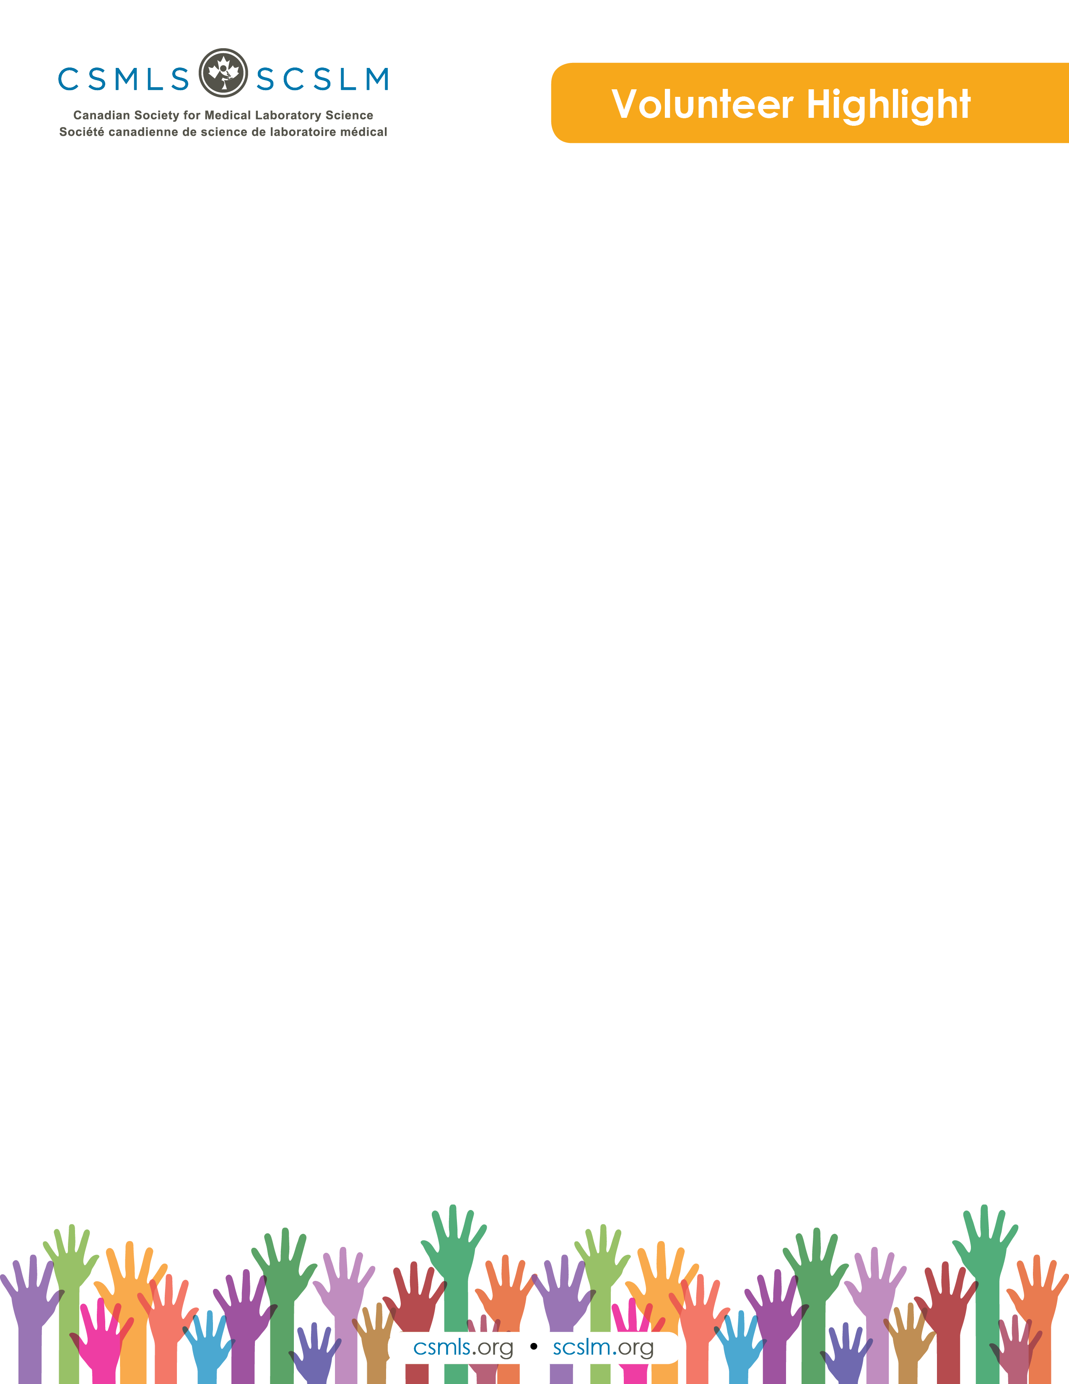

Maria Roussakis

My name is Maria Roussakis, and I am a bit new to the medical laboratory profession, having graduated in 2016 from the University of Ontario Institute of Technology. I work as a medical laboratory technologist within the chemistry, hematology and transfusion medicine laboratories. I am also in the process of completing a MSc in Health Science Education at McMaster University. When I am not working or doing course work, I enjoy spending time with my hedgehog Lucie!

What is your involvement with the CSMLS Research and Special Initiatives Department?

Previously with CSMLS, I have served as a volunteer on their Exam Panel as well as the Angoff Panel in setting the passing grade for the certification exams. Currently, I am serving on the Choosing Wisely Medical Laboratory Professional Panel as an Invited Guest since I am an emerging health professional. In this role, I am contributing to the Choosing Wisely Canada recommendations that will be set for laboratory professionals. Throughout this process in creating Choosing Wisely Canada recommendations, I have met with other panel members and brainstormed areas in which these recommendations could be of use.

Why do you value your partnership and project(s) with CSMLS?

I am very thankful to be part of such a project with CSMLS, considering I am very new to the medical laboratory profession. By taking part in this project, I have had the opportunity to learn about different practices occurring throughout Canada as well as various struggles that certain areas face.

How will your project(s) help the medical laboratory profession?

By taking a part in creating a Choosing Wisely Canada recommendation list for laboratory professionals, the medical laboratory profession in Canada will be following the same standards as other health care professions, adopting the reduction of unnecessary testing, treatments and procedures. With a set of recommendations in place, laboratories across Canada will have a standard to uphold and ensure inappropriate wastage is reduced.