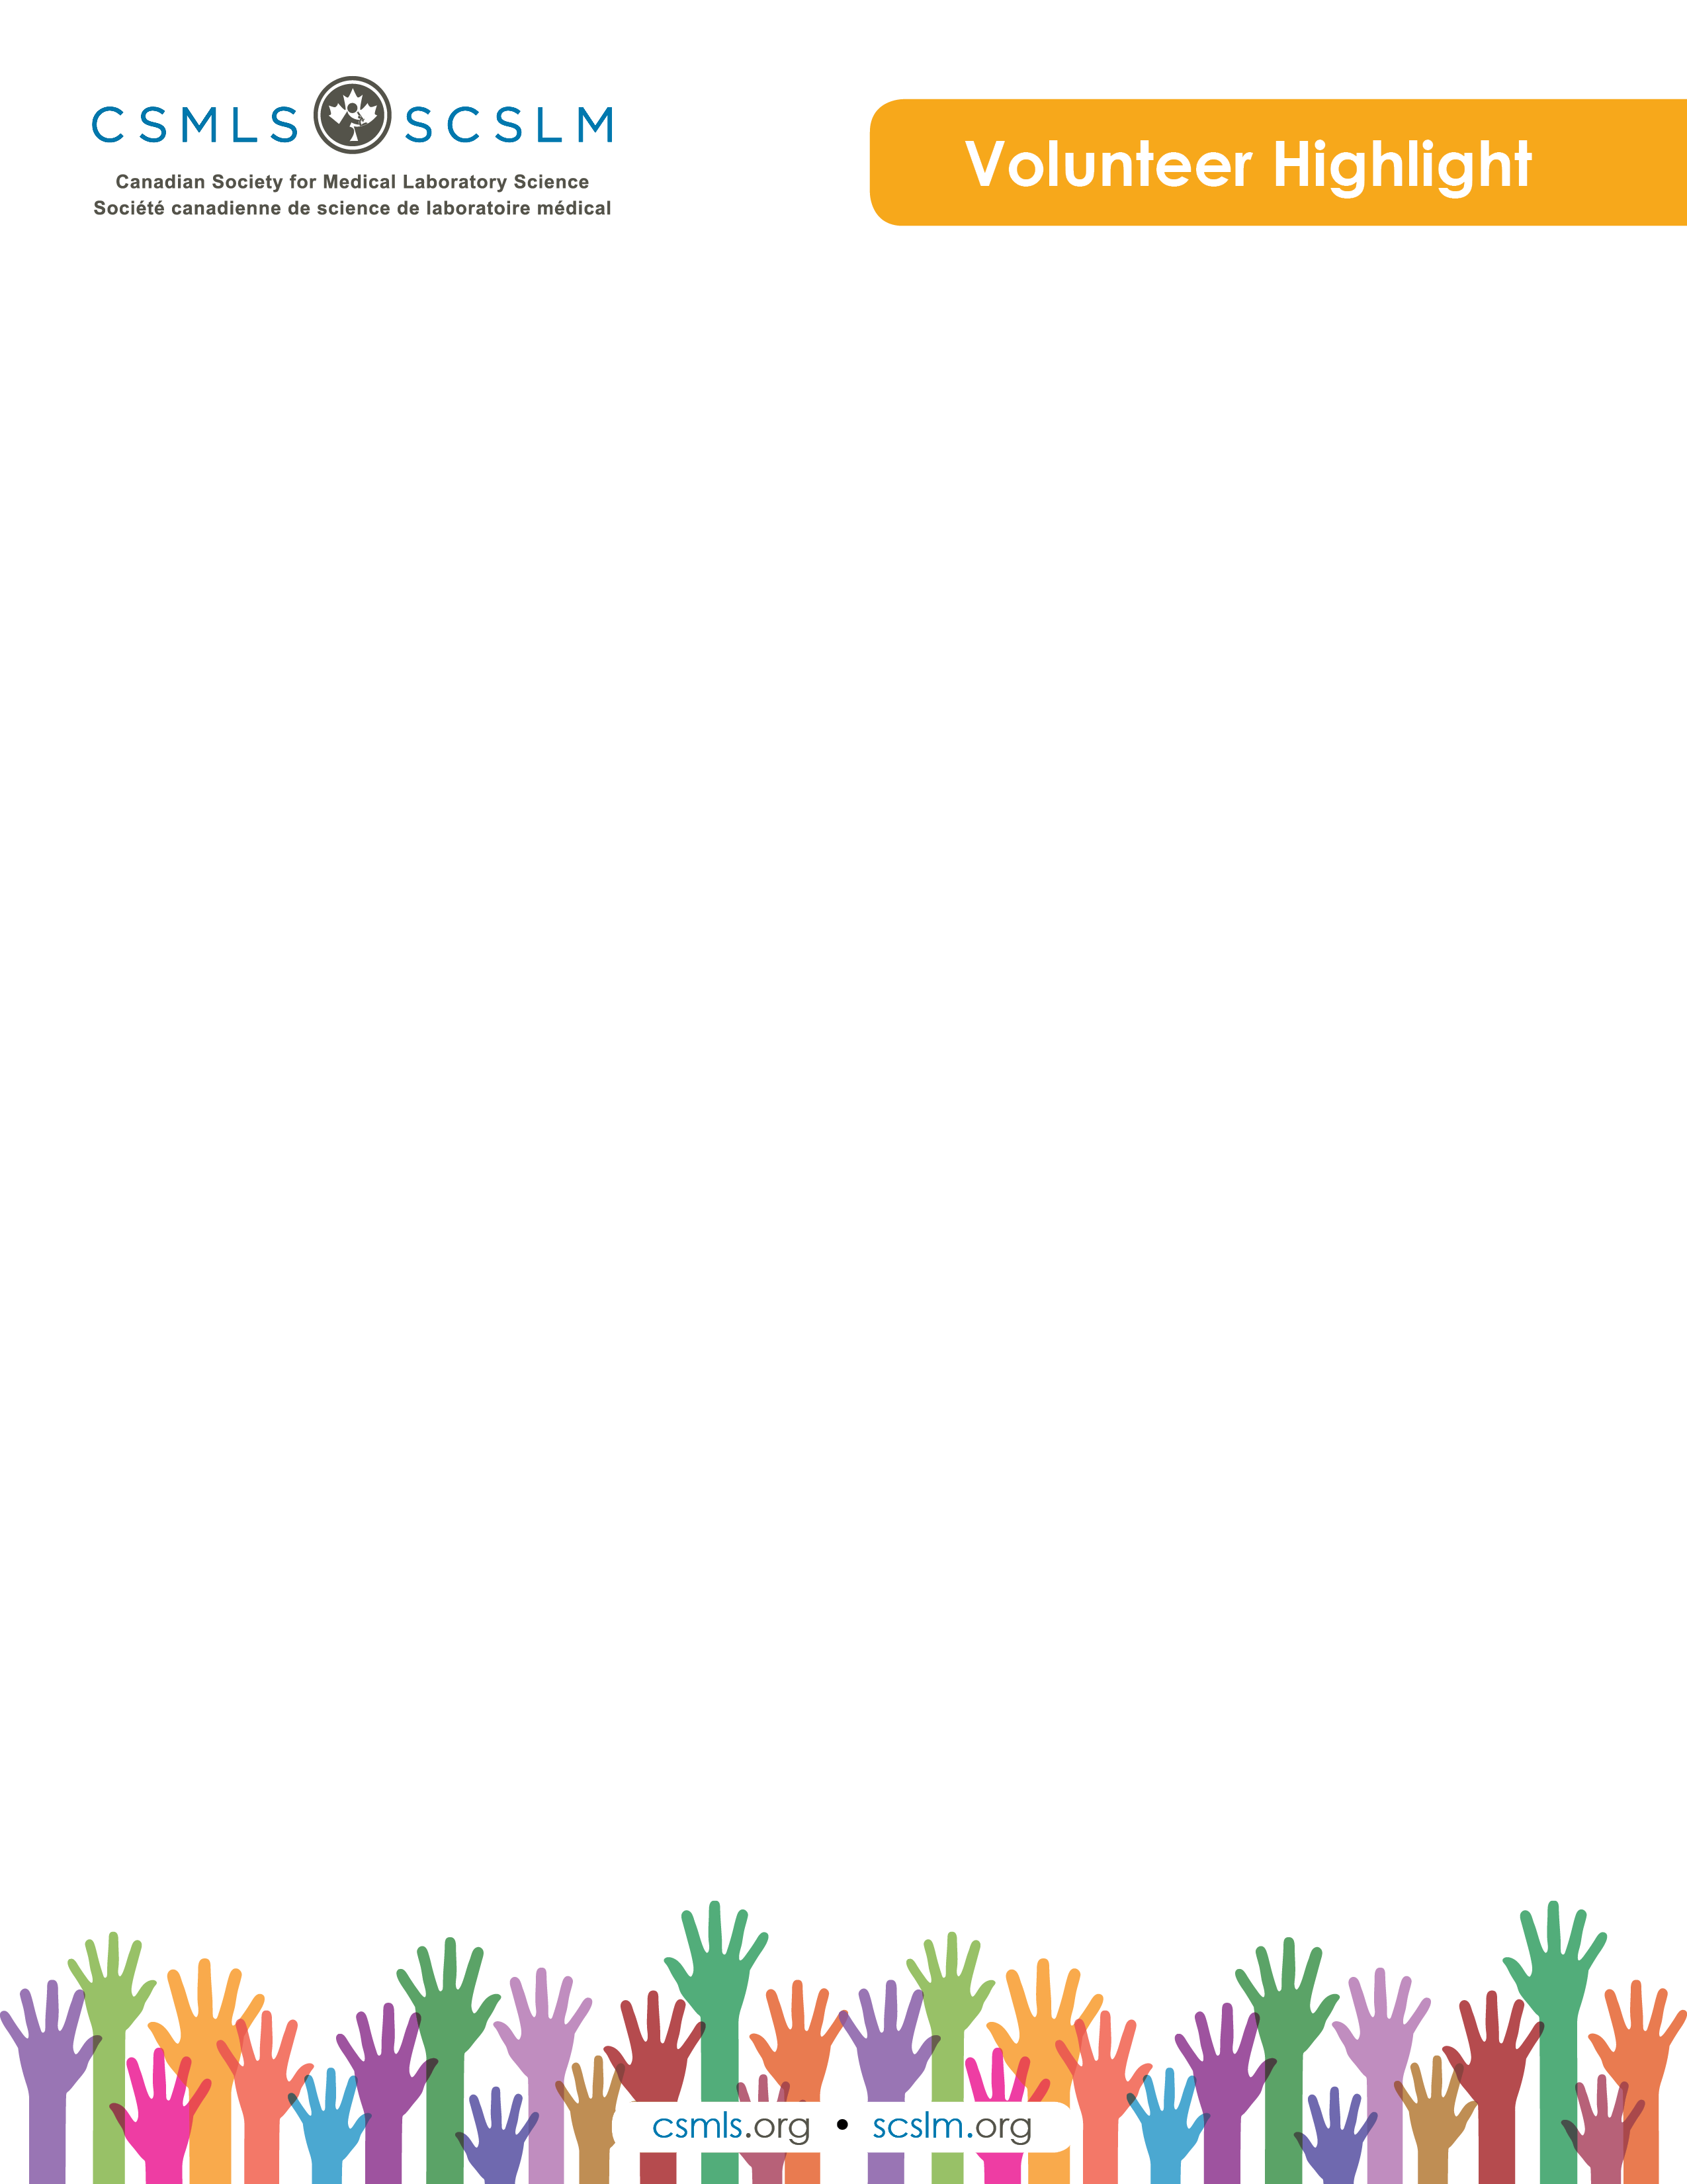

Brendan O'Brien

My name is Brendan O'Brien, and I am a cytotechnologist working with Eastern Health in St. John's, NL. Since completing a Bachelor of Health Sciences at Dalhousie University in 2016, I've had a keen interest in the medical laboratory sciences and health research. My main area of interest lies within cancer screening. During my time at Dalhousie University, I completed research studies assessing ovarian cancer screening modalities as well as breast cancer risk-reducing surgeries in women with genetic mutations for BRCA 1 and 2. At my current place of work with Eastern Health, I’ve completed research projects assessing gynecological screening and lung biopsy procedures. In addition to these projects, I am also currently assisting in facilitating a Critical Research and Appraisal course at Dalhousie University.

What is your involvement with the CSMLS Research and Special Initiatives Department?

As a member of the CSMLS, I have had the opportunity to get involved with various projects, serving on the Exam Panel for Diagnostic Cytology, participating on a national graduate panel regarding clinical placement and education and being a member of the Accreditation Taskforce for medical laboratory programs in Canada. I have also partnered with the CSMLS on various research initiatives exploring simulation in medical laboratory education and recently investigating the changing climate of the cytology profession and resource shortages facing laboratories across Canada.

Why do you value your partnership and project(s) with CSMLS?

The CSMLS has supported me in facilitating projects that are personally interesting to me. By engaging with other members, graduates, students, education institutions and stakeholders, we are able to look to the future of the medical laboratory profession. Taking part in these various initiatives enables me to give back to my profession and aid in the evolution and improvement of the medical laboratory sciences.

How will your project(s) help the medical laboratory profession?

In working with the CSMLS, it is my aim to influence positive change within the medical laboratory sciences. Through evaluating current needs and trends in the workforce, investigating simulated learning and working diligently to focus the national exam, we are better able to make improvements in areas like clinical education. It is my hope to continue to work with the CSMLS on various projects to benefit the medical laboratory community as the scope of our profession proceeds to evolve.