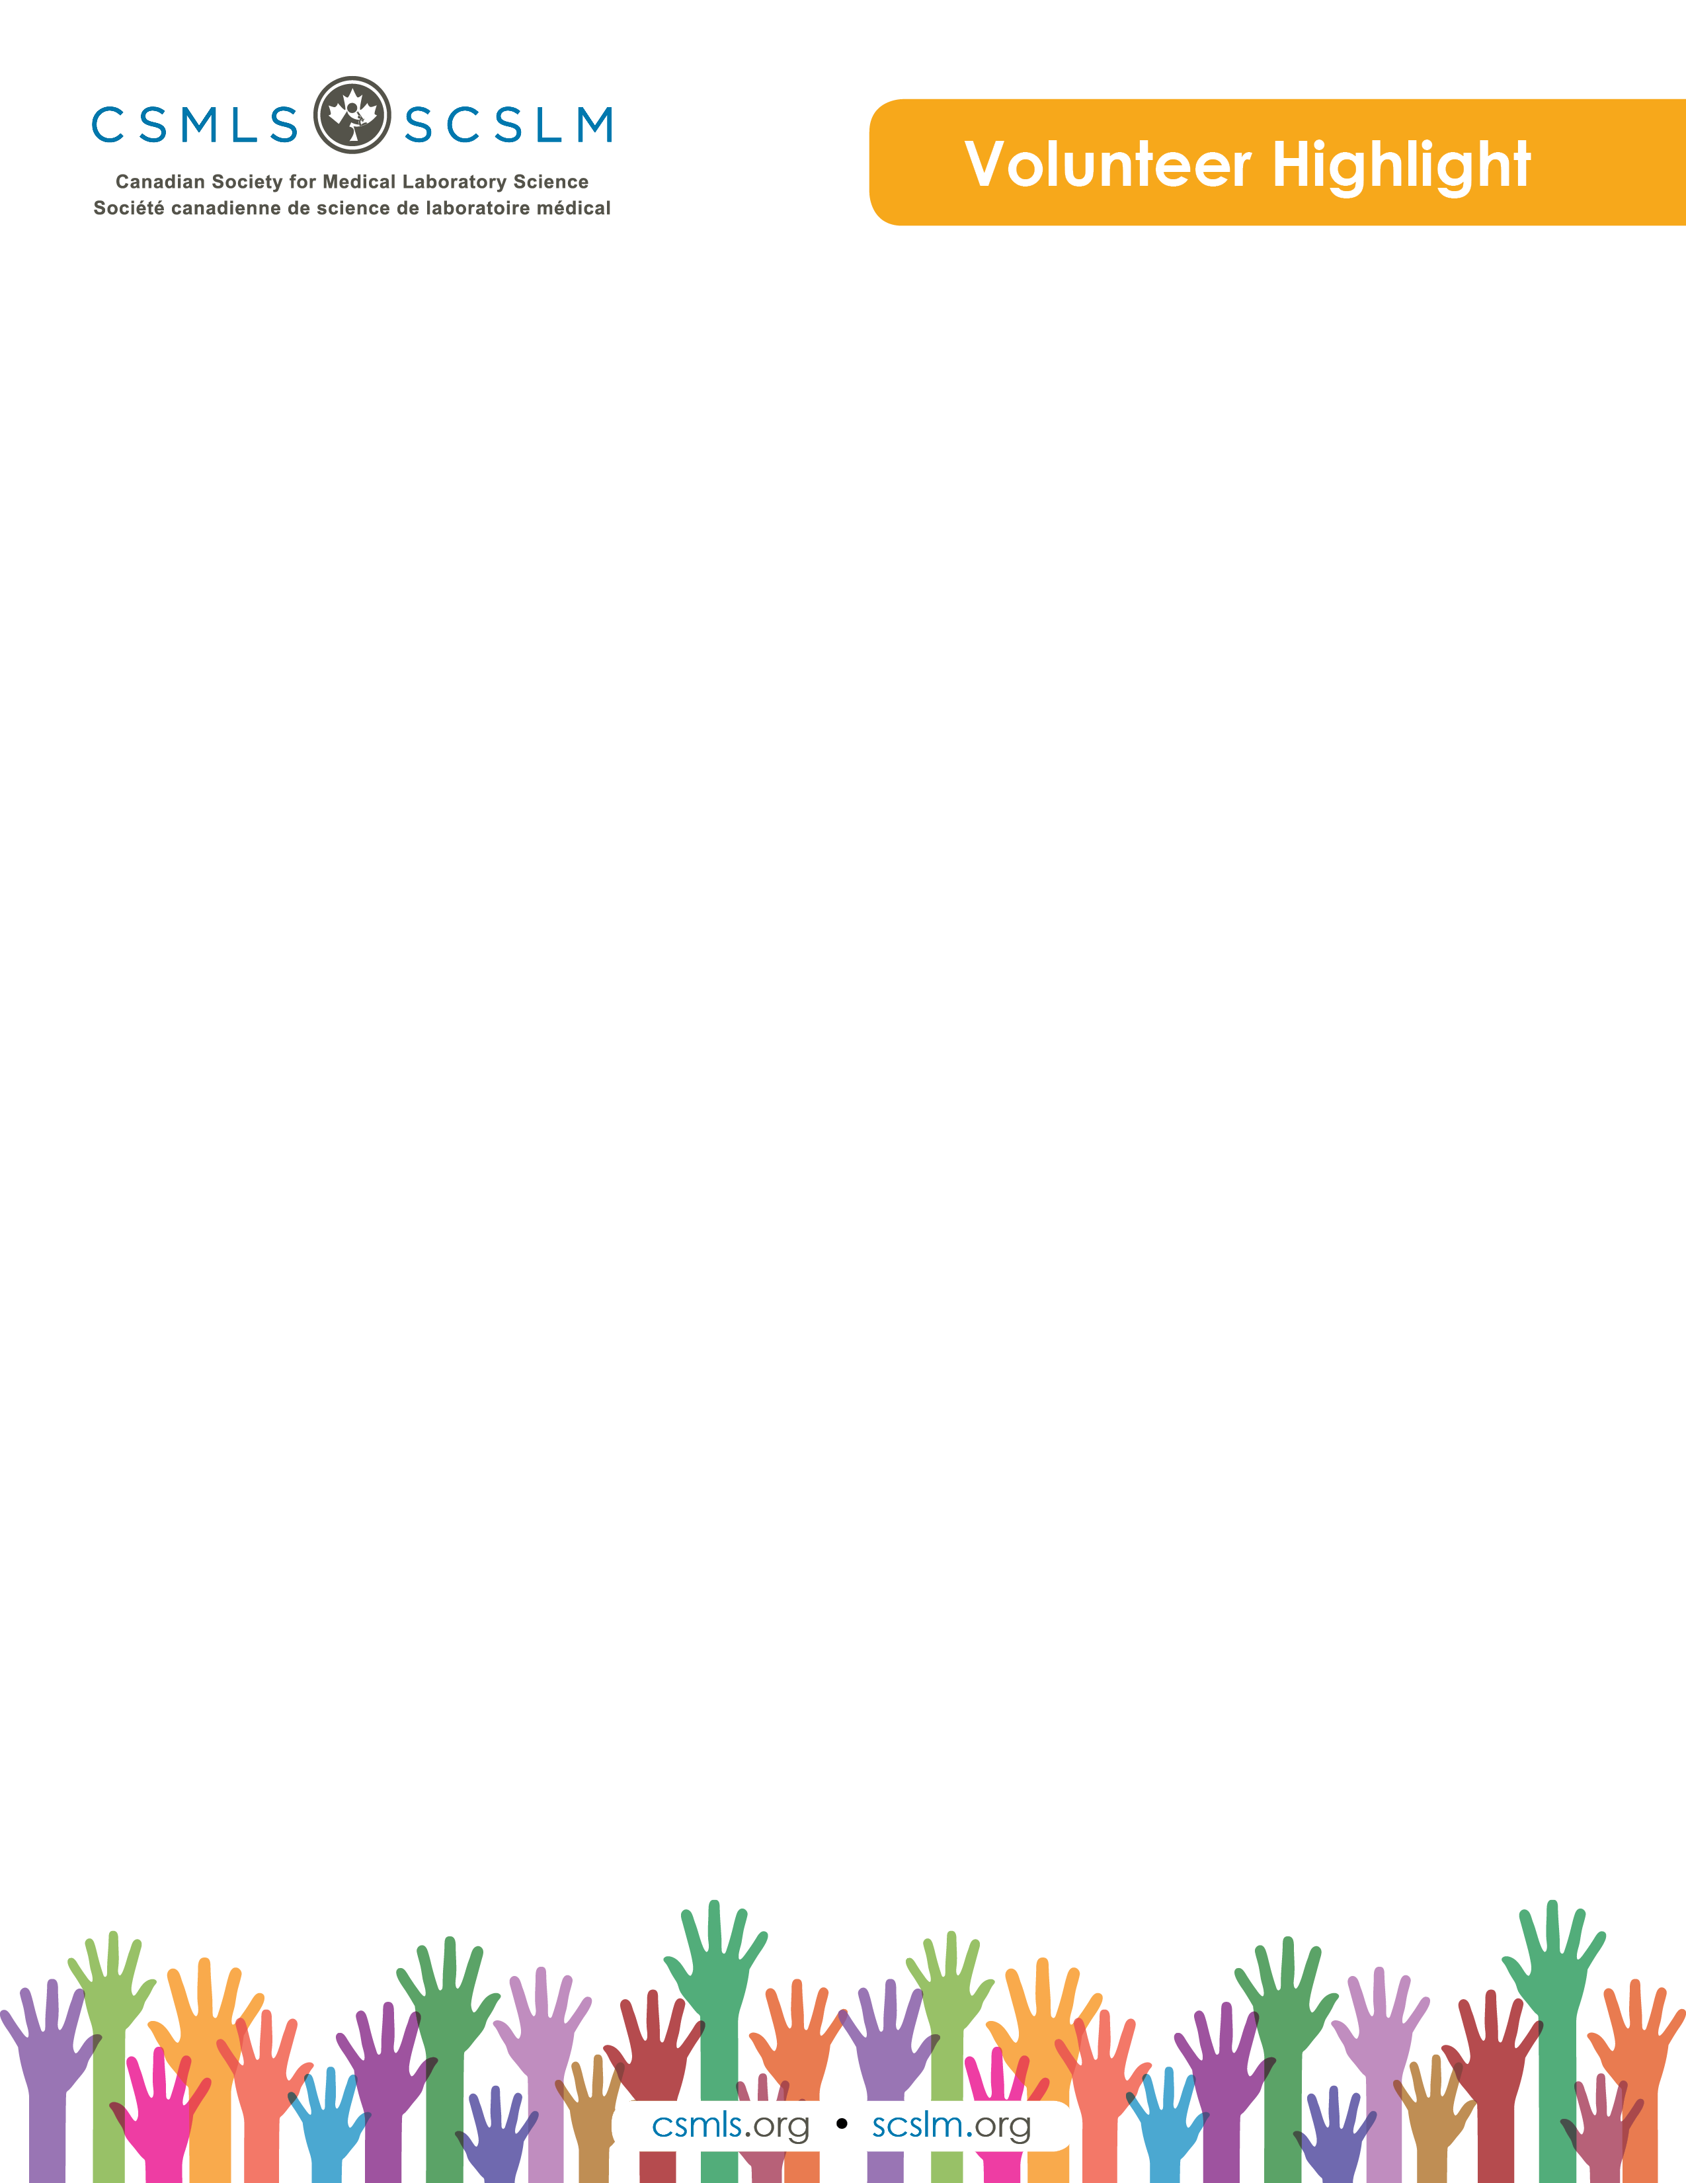

Oliver Li

I am Oliver (Xiaoquan) Li, currently working in the department of microbiology at Mount Sinai Hospital in Toronto. I became a CSMLS certified MLT four years ago and am taking every opportunity to contribute to the medical lab community and help people on their MLT pathways.

What is your involvement with the CSMLS Research and Special Initiatives Department?

I am partnering with CSMLS as a volunteer on a 24-month CSMLS Diversity Training Project from the perspective of an internationally educated MLT. This project is funded by the Ontario Ministry of Citizenship and Immigration, with the goal to develop two or three diversity products to meet the specific needs of three groups of people in the MLT community. As one of the working group members of the advisory committee, I provide ongoing guidance, input and support to the project. As an MLT educated outside of Canada, I am able to provide input into the form and content of the diversity products, assist in personnel recruitment and methodology used and review survey and other evaluation materials in the preliminary and pilot phases of the project.

Why do you value your partnership and project(s) with CSMLS?

As Confucius said, “Walking along with three people, my teacher is sure to be among them.” Through partnership and projects with CSMLS, I have the wonderful chance of learning from everyone I am partnering with. Also, I am building up my network and connecting with other lab persons and my peers in this field.

How will your project(S) help the medical laboratory profession?

I successfully became a CSMLS certified MLT in Canada in 2015. I could not have embarked on my lab journey so soon in Canada without the great help from CSMLS. I would like to be involved more and contribute more through partnering with CSMLS to help more lab professionals on their pathways to professional success.