What’s the Describing-Your-Profession Conversation About?

“I find it's hard to explain what we do.” | “Patients think we are nurses because we wear scrubs.”
~ CSMLS Members
Why this topic? The privilege of being called a medical laboratory professional (MLP) is bestowed upon a candidate who has satisfactorily completed their academic requirements and, for many, passed a certification exam and obtained their license to practice. We proudly tell others about our credentialed titles during the initial days, smiling ear to ear for our accomplishments. Time rolls on and we establish ourselves within the laboratory system, seek partnerships, expand our families and enjoy the luxuries that come with a consistent pay cheque.
Then, something happens. In general discussions with CSMLS members, a language degradation pattern has emerged and it has caught on our radar. What does that mean? Some MLPs are wondering how to describe the profession and others are forgetting to tell people about the profession. We can see glimmers of it in our evidence-informed projects and annual membership survey comments. These combined sources make us wonder if MLPs are falling into two habits:
- Somewhere along the way, we stop consistently telling patients (and health care professionals) that we are MLPs. Sometimes, patients assume MLPs are nurses because we don’t announce our profession when first meeting.
- In addition, we lose the words to describe the grandness of our work and the important characteristics of the people doing the jobs (with and for patients). Many of us consider it as a hidden profession and use introverted-related adjectives to describe MLPs.
Why? That part is a little fuzzy. Perhaps it’s because it is not a priority when STAT requests are flying at us every day. Why think about such a small concept when we are bogged down with increasing workload levels?
In a CSMLS survey to the public, only 10% of participants were “extremely familiar” with the role of a medical laboratory assistant. In all fairness, we can see why saying, “Hello, I’m Doctor Smith” or “I’m Nurse Nancy” is easy to maintain interactions because the introduction is short and sweet. It clearly provides patients and health care professionals a picture of who they are and what they do with a single word (mind you, they have their own title struggles as well). Saying, “Hello, I’m Medical Laboratory Assistant Jennifer,” is much more of a mouth full and patients don’t always know what MLPs do.
Maybe it’s time to think about the impact of not stating our titles and not having key adjectives to describe our profession. This is not a new thought, though. The concept of polishing the image of MLPs in the eyes of others is an old story. However, something needs to change on a large scale for the future to be different.
We believe it’s important to use descriptive language in each and every interaction. It’s a learning opportunity for the listener, and it opens room for discussion about who you are compared to other health care professionals.
In fact, it is probably the simplest and easiest change in behaviour
each CSMLS member can make to increase the profession’s visibility in Canada.

How does the med lab fit into the describing-your-profession conversation?
We fit into the conversation because we should create some uniformity in our profession’s descriptive language while promoting best-practice interactions with patients and other health care professionals.
- Fifty-nine per cent of Hot Spot Survey respondents did not believe MLPs describe their profession consistently in Canada.
- Eighty-two per cent believed there should be national awareness of descriptive language for our profession.
Let’s break it down in two ways and discuss why some language uniformity can be valuable.
Patient’s Perspective: The number of titles in health care is flourishing as the system is pressed to accommodate specialized duties due to technology, treatment options and process need. It may encourage choice and uphold the principles of skill mix but can also create confusion.
Did you know? Statistics Canada’s National Occupational Classification (NOC) system lists 40 examples for medical laboratory technologist titles (NOC 3211), 30 examples for medical laboratory technicians and pathologists' assistants (NOC 3212), 138 examples for registered nurses and registered psychiatric nurses (NOC 3012) and 118 examples for medical radiation technologists (NOC 3215). That is a lot of titles for only four professional groups! If these professional groups predominately wear similar scrubs to work, it’s not reasonable for a patient to be able to distinguish who is who without a little help.
By consistently providing your general title to patients (ask your workplace what they suggest), you are respecting the individual, establishing rapport and asking to be an active participant in the encounter (contributing to the Patient’s Bill of Rights). Also, you can showcase how you are an important part of their patient journey (from the day they are born and until the end). If the discussion arises, it’s great to promote the work of your colleagues. Next time you are in this situation, try to think of a different approach to take than this:
- “Basically, I only tell others I am a medical technologist if it comes up in conversation. Most patients think I am a phlebotomist because I am drawing their blood.”
- “I tell patients I'm ‘from the Lab’ and I'm here to collect some blood. I don't specifically tell them I'm a technologist.”
We don’t expect you to get too detailed about your job with everyone! Patients recall as little as a fifth of information discussed during appointments and immediately forget 40%–80% of the content of their medical encounters. Thus, many patients won’t remember the details of your job title such as a sub-speciality designation. They will remember that you are from the laboratory and part of their medical investigation and care. They will understand that MLPs are not a hidden profession but one that stands with them at every step of their journey.
Public Awareness: One type of question CSMLS hears regularly is “How can an organization increase the public’s awareness of the profession?” We are working on ways to do this, and we recognize that the cost to run TV commercials isn’t always good value for your membership dollars. For example, a 30-second commercial mid-season of Grey’s Anatomy costs over $200,000! That doesn’t even account for the cost to make the commercial. However…
- If 440 million tests are conducted in Canada annually and in one-twentieth of these appointments the patient is meeting an MLP for the first time, there are 22 million potential opportunities to make people aware of your profession.
- It doesn’t cost you a penny (or nickel).
Hot Spot Review survey respondents were open and honest with us about how often they announce their professional title (thank you!). Our previous information gathering was confirmed by their responses; MLPs are likely telling patients their profession about half of the time and approximately a quarter of the time to other health professionals. Unfortunately, that means three quarters of the opportunities to advocate for your profession and be involved in clinical conversations through providing your expertise and increasing the awareness of your profession could be lost. It also means half of the patients seen might attribute your wonderful work to other professions, and that’s lost opportunities to increase the public’s awareness (about 11 million opportunities).
Group | % of participants who “always” state they are an MLP  when meeting a person for the first time
Patients | 48%
Health care professionals | 28%
New acquaintance | 12%
Visitor to the lab | 32%
Student | 42%

What descriptors should be use to describe our profession?
At the moment, we don’t have a refined list of adjectives compiled, but we have a starting point for you to think about and use. We asked participants of the Hot Spot Review survey, “What personal characteristics, behaviours and values are beneficial for medical laboratory professionals?” The list was long! One reason why respondents may have provided us with so many words could be because MLPs have complex jobs that require a multitude of skills and abilities. Based on the survey results and CSMLS discussions with members, it is also likely that there isn’t consistent language used nationally to describe our profession and professional characteristics.
Here’s what respondents felt showcased the profession’s characteristics, behaviours and values:
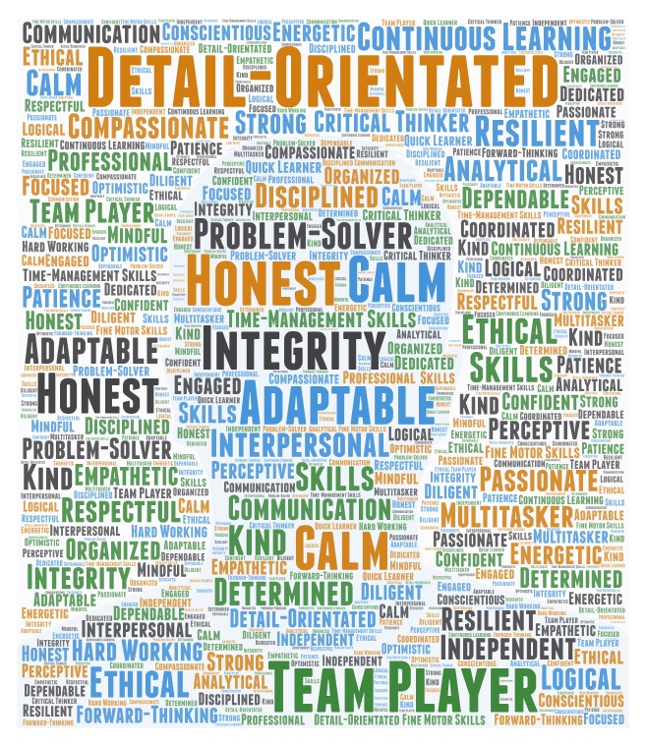

How else can MLPs contribute?
Being an MLP doesn’t mean you only have to think of your profession in terms of lab duties. It is a profession to be proud about. You are also a part of the larger health system and can add your voice to conversations with other health care professions.
Add your opinion to the conversation and let your organization know that MLPs have something to contribute! You can use the following as a starting point:
- What is the standard for introducing yourself to patients? Does your lab have a formal or informal policy?
- Talk to your coworkers and listen to their word choice. Why are they proud to work in this profession? What are the descriptive words they use?
- Brainstorm in a meeting some adjectives that can be use to promote the lab. Use these when talking to other health professionals about your work.
- If you have time and it’s an appropriate moment, ask a patient what they know about MLPs and help create a fuller understanding with them.

Get informed. Get motivated. Get talking. Get political.
*The data in this article should not be considered generalizable to all medical laboratory professionals
as it was collected as part of a CSMLS quality assurance project. *

We understand that one-twentieth is a guess. It’s more about the potential loss than nailing down a number. Even if you use one-one hundredth as the value, that is still 4.4 million lost opportunities.

