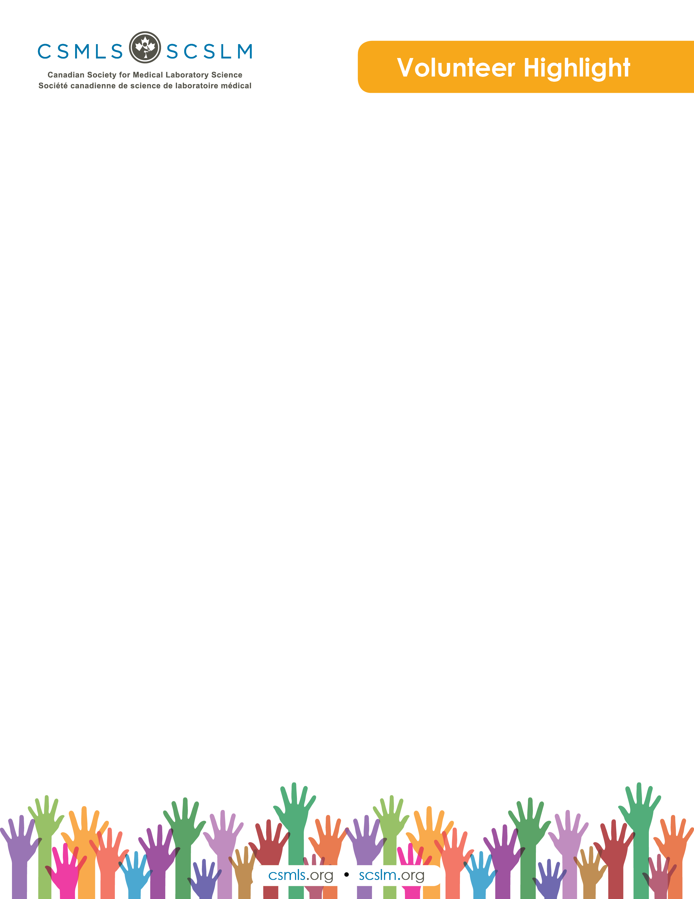

Bernie Hartung

Hello, I am Bernie Hartung. I have been an MLT since June 1982 and a member of my profession since then also. I have lived in the Owen Sound, Ontario area my whole working career.

I enjoy being in nature; we have 12 acres to enjoy. It is very satisfying to look out our windows to see the wildlife around us.

Throughout my career, I have been on a variety of committees: national, provincially, the hospital and also for my church.

What is your involvement with the CSMLS Research and Special Initiatives Department?

I volunteer as a member of the Research Ethics Board (REB) for the CSMLS. I was also on this committee for Grey Bruce Health Services.

I also volunteer as a member of the Diversity Advisory Committee (DAC). This committee is looking into developing resource material to assist foreign-trained MLTs to enter the Canadian workforce.

Why do you value your partnership and project(s) with CSMLS?

The CSMLS is the national voice for our profession. I care about the profession and want to do my part to help advance the profession.

How will your project(s) help the medical laboratory profession?

The DAC is looking at ways to help internationally educated medical laboratory technologists (IEMLTs) to receive certification and enter the Canadian workforce.

The REB makes sure all research being conducted, through the CSMLS, will not cause harm to those involved.