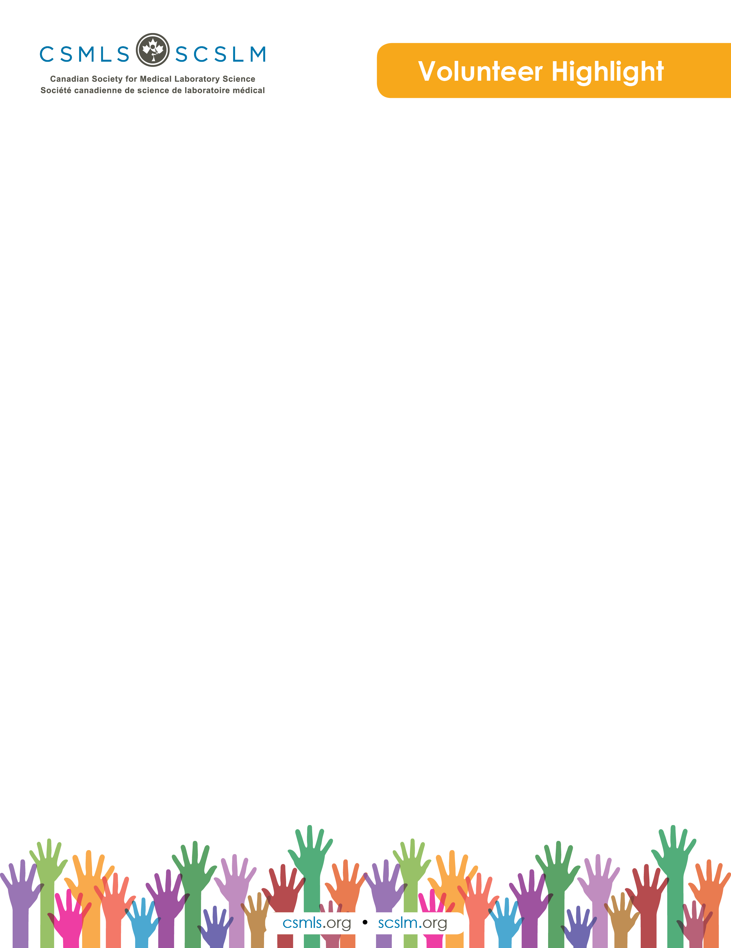

Stephanie Eccles

Hi. I am a general MLT who has been working in the profession for over 15 years. I love to read, learn new things (currently doing my degree) and spend time with my niece.

What is your involvement with the CSMLS Research and Special Initiatives Department?

I have been given many opportunities to volunteer with the CSMLS over the years but am currently on the Exam Panel, Scientific & Education Review Committee, Angoff, item writing and, most recently, as part of the diversity project and Choosing Wisely Canada.

Why do you value your partnership and project(s) with CSMLS?

CSMLS continues to be the leader and voice of lab professionals in Canada and a valued presence worldwide.

How will your project(s) help the medical laboratory profession?

The diversity project is working to provide educational opportunities to enhance our relationships and provide great foundations with those professionals that have originally trained outside of Canada.

The Choosing Wisely project is working to provide resources and recommendations to improve patient safety while ensuring that the testing provided allows for treatment and diagnosis.