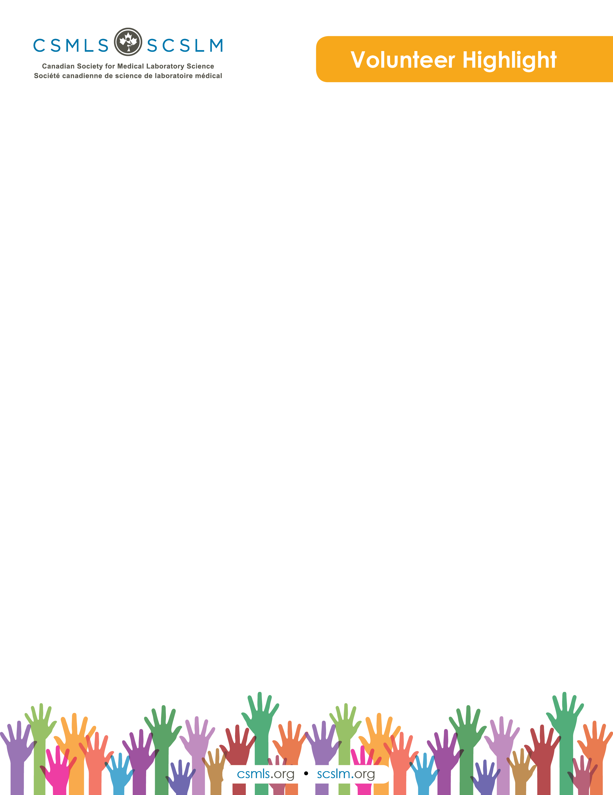

Jingwei Chen

Hi, everyone. Thank you for taking the time to read my short profile. My name is Jingwei Chen, and I keep telling people I’m a new med lab grad, but do you really count as new if you’ve been working for a year now? Let’s compromise on newish. So I’m a newish grad, a shameless morning person and a CSMLS volunteer.

What is your involvement with the CSMLS Research and Special Initiatives Department?

I am a proud graduate of the Michener Institute, and its outstanding faculty has always encouraged students to become involved in med lab efforts and organizations. Sometimes you get lucky and an opportunity is posted online, but in my experience, the best thing to do is to take the initiative, reach out yourself and ask if you can help with anything. That is exactly what I did. The first project I helped with is exploring the various changes and strategies that academic programs are piloting to ensure sufficient clinical training in a time of looming medical laboratory personnel shortage. And as you can see, I am also involved in another project as the coordinator (and guinea pig) for this series of CSMLS Volunteer and Partner Highlights.

Why do you value your partnership and project(s) with CSMLS?

Volunteering for CSMLS is my way of supporting our profession. It’s a small contribution to be sure, but I find the time and effort I spend to be personally enriching and meaningful.

How will your project(s) help the medical laboratory profession?

Broadly speaking, I hope my projects make a positive impact on our profession, respectively by sharing knowledge and by recognizing remarkable people. I also not-so-secretly hope that my profile will inspire current and aspiring medical laboratory professionals to get interested and involved beyond pure benchwork!