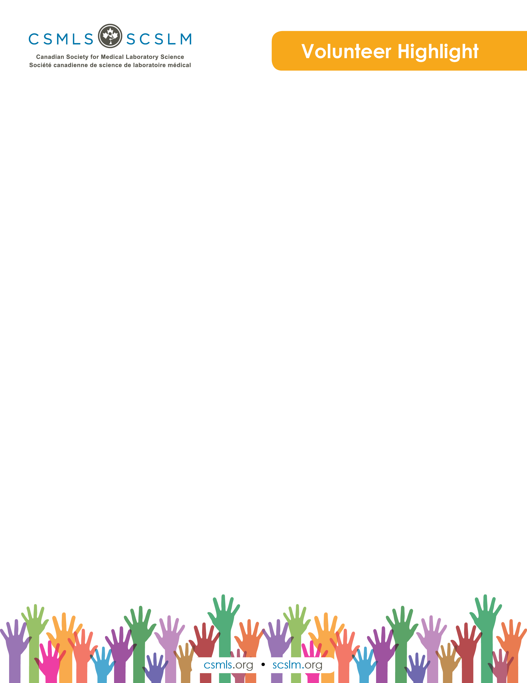

Mary Bylhouwer

I have been fortunate to have a career that I have always been passionate about and it has always included medical laboratory technology in one way or another. After graduation, I was fortunate to get a position at Hamilton General Hospital, working primarily in clinical chemistry with involvement in clinical student training. It was this interest in students that led me to take a leap from my full-time technologist position to a temporary position in the Mohawk College med lab program. That position changed and instead of a temporary stay, I remained at Mohawk until my retirement. However, my career was anything but static. The med lab program closed at Mohawk, but I was able to connect with my med lab roots by moving to continuing education. It was in this final position that I was able to have the amazing experience of working with a fantastic team to design and deliver Mohawk’s Bridging Program for Medical Laboratory Technology. It was humbling to help internationally educated technologists achieve their goals of certification in Canada. The continuing education role also allowed me to work with medical laboratory technicians and gain better insight into their needs and perspectives. I feel very fortunate to have been part of this profession and to have had so many rich experiences.

What is your involvement with the CSMLS Research and Special Initiatives Department?

While working in continuing education, I enjoyed an ongoing collaboration with CSMLS. CSMLS supported our programs by coming to speak to our students to offer advice and information on topics related to certification and exam preparation. I turned to them for guidance to ensure that education requirements were being met for internationally educated medical laboratory technologists. I consulted with them in regards to certification for medical laboratory technicians. I also volunteered on several CSMLS advisory committees that were involved with projects relating primarily to internationally educated technologists.

Why do you value your partnership and project(s) with CSMLS?

I continue to serve on advisory committees with CSMLS that are primarily related to internationally educated medical laboratory technologists. I value being part of these committees since it still gives me an opportunity to work with other professionals in the field. This allows me to stay active in my profession and provides me opportunities to learn and grow.

How will your project(s) help the medical laboratory profession?

I feel that my personal and professional experiences can provide insight to the advisory committees that I am part of. These advisory committees, in turn, try to provide support for projects that try to find solutions to challenges faced by medical laboratory technologists from outside of Canada.