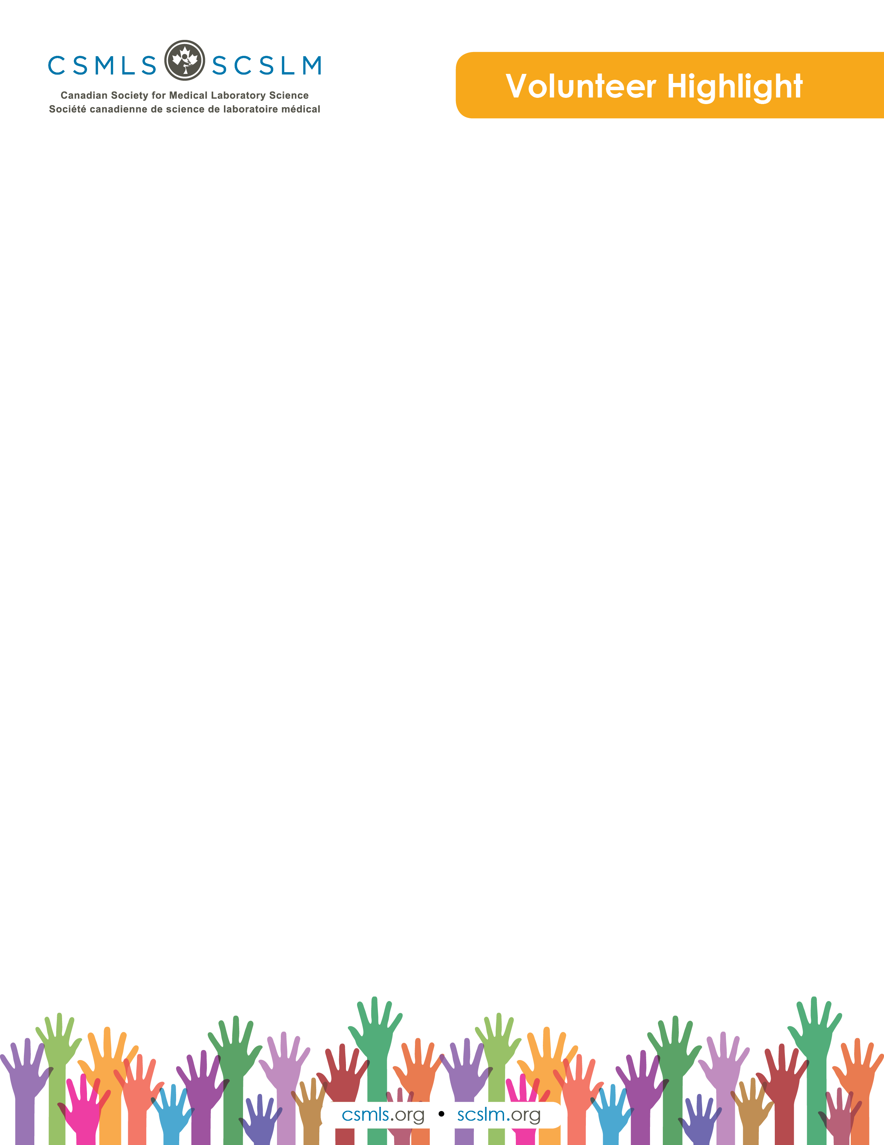

Christine Bruce

My name is Christine Bruce. I have been an evolving senior leader in the Canadian medical laboratory and diagnostics services industry for just over 20 years in both the private and public sector.

Today I am the administrative director for pathology and laboratory medicine at the Grand River and St. Mary's General Hospitals in Kitchener.

I have committed my career to improving patient care by deeply investing in health care workers, and creating great places to work, so that those workers can influence a great patient experience.

What is your involvement with the CSMLS Research and Special Initiatives Department?

I am partnered with CSMLS as a representative for Grand River and St. Mary's General Hospitals in Kitchener.

I am on the committee that has committed to develop two to three diversity products aimed at meeting the specific needs of MLT workplaces in Ontario. Diversity products in this context may take a variety of forms and include instructional videos, certifications courses, workshop curriculum, tip sheets and human resources checklists.

My role is to participate and collaborate with the other committee members on desired solutions and to support guiding the tools being developed as a key stakeholder and user of the products in my workplace.

Why do you value your partnership and project(s) with CSMLS?

This partnership is important to me and my organization as CSMLS is what I consider to be the key opinion leader for laboratory medicine in Canada. I reference the Society often to be certain I am providing the best guidance for my program in my organization and to gain insight for future planning. It is important to me to be at the table and participate in decision making, and so this partnership is a great platform to reinforce that.

How will your project(S) help the medical laboratory profession?

As the shortage of health human resources loom in lab medicine, I feel that integrating foreign-trained resources into the workplace has become paramount to our sector’s success. This project is vital to both employers and future employees to have a great place to work and to maintain a healthy, thriving workforce.