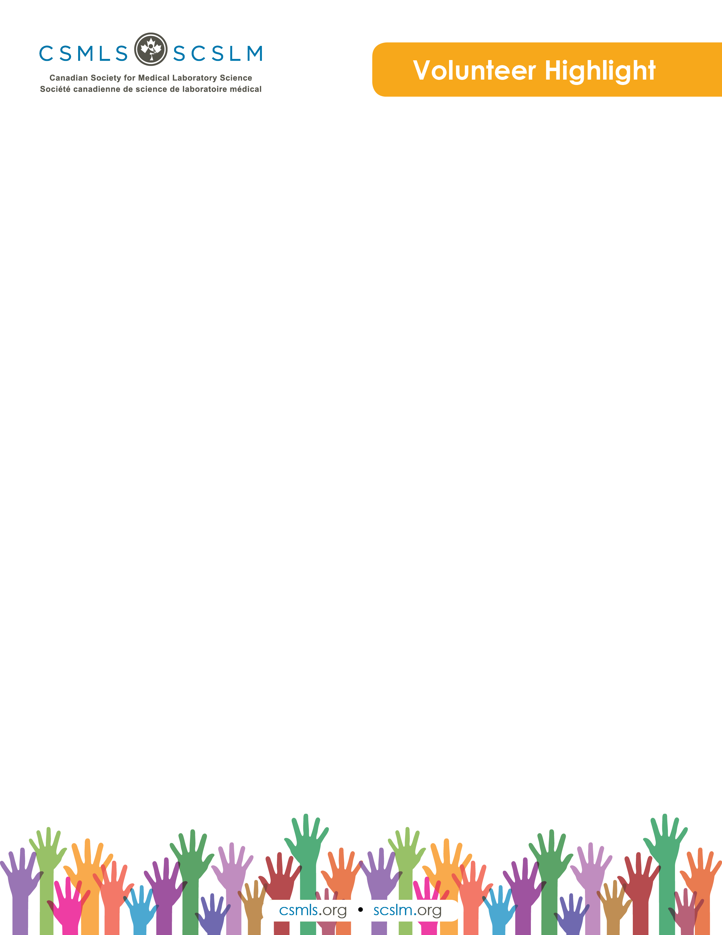

Julia Acker

My name is Julia Acker, and I am a fourth year medical laboratory science student from the University of Ontario Institute of Technology. I am very passionate about the work conducted in clinical laboratories and am excited to begin my career as a medical laboratory technologist.

What is your involvement with the CSMLS Research and Special Initiatives Department?

I am a CSMLS student research volunteer as part of my clinical project for my undergraduate degree. I have had the honour of working alongside Laura Zychla throughout the 2018–2019 school year on a project entitled, “Exploring the Impact of Cannabis Legalization on the Canadian Laboratory.” Data collected for this investigation was obtained via one-on-one interviews with those currently working in a management role within the medical laboratory field in order to determine and track the current changes occurring in the clinical laboratory as a result of cannabis legalization. This experience has been very rewarding as I have been able to work through the entire research process on a very interesting topic; I have learned many new things and respect all the hard work and dedication that goes into research.

Why do you value your partnership and project(s) with CSMLS?

The CSMLS is an amazing organization that helps medical laboratory professionals reach their full potential by advocating for the profession and providing excellent resources for those interested in medical laboratory science. I value everything the CSMLS does in order to promote, maintain and protect the professional identity and interests of medical laboratory professionals. Volunteering for the CSMLS has reinforced how supportive this professional association is for its members and associates.

How will your project(s) help the medical laboratory profession?

Partnering with the CSMLS for this project will have an excellent outcome for those working in the medical laboratory profession. By conducting the current research, the results are anticipated to shed light on how practice has or has not changed since legalization and support CSMLS initiatives to improve the way medical laboratory professionals adapt to future changes.