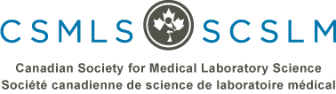

The Simulation Knowledge Exchange – Research Network would like to present to you:

Simulation & Clinical Placement National Discussion – Teleconference Series

Employer & Clinical Instructor Perspectives – Forum Summary

Join the discussion!
May 22nd 2017, 12-1pm EDT
Title: Simulation and Clinical Placement Employer Forum 2017 - Continuing the Discussion
Topic: The Employer Forum, held by CSMLS on April 29th (Toronto, ON) and co-hosted with Michener, will result in discussions that make change - just as the Educator Forum in 2016 did! Join this presentation to hear what was discussed at the Forum, the solutions contemplated and the opinion of experts on how to derive change that fits our future. Also, find out the results of the CSMLS Employer Survey and what clinical placement teams need to build a bright future for students and staff.
Presenter: Laura Zychla, CSMLS Researcher
Event Details: Check out the CSMLS event page website for details (www.csmls.org) and access to the teleconference! Handouts and slides may be posted on the event page.
Teleconference Schedule: Join us on the 4th Monday of each month, 12-1pm EDT. Add it to your calendars now! It is open to all CSMLS members and medical laboratory stakeholders.
For more details and upcoming topics, go to the CSMLS Events page!

