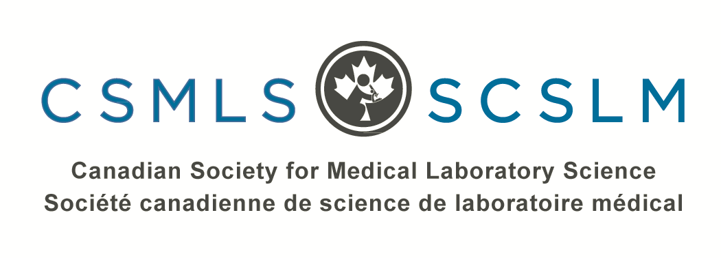

Final Report and Project Evaluation
Practice Exams for Internationally Educated Applicants

Prepared for: Ontario Ministry of Citizenship and Immigration (MCI)
Prepared by: Canadian Society for Medical Laboratory Science (CSMLS)

Keith Johnson – July, 2019

Contents
Introduction 3
Methodology 4
Deliverables 4
Item Writing 4
Item Development 4
Evaluation 5
Pilot Phase 5
Feedback and Analysis 6
Findings and Results 11
Number of Practice Test and Questions 11
Number of IEMLTs in the Pilot Phase 11
Number of IEMLTs Licensed 12
Number of IEMLTs Employed 12
Number of Annual Users 12
Appendix A: List of Item Writers 14
Appendix B: Number and Types of Items Developed 15
Appendix C: CSMLS REB Approval 16
Appendix D: Numeric Reporting Template 17

Introduction
To practice in a regulated jurisdiction (with the exception of Quebec), all prospective medical laboratory technologists must apply to the Canadian Society for Medical Laboratory Science (CSMLS) and pass the certification exam. The majority of internationally educated applicants who applied to the CSMLS indicated they apply to work in Ontario (70%). In 2016, a total of 863 applicants wrote the certification exam for the first time, of which, approximately 139 were internationally-educated applicants (IEMLTs).

IEMLTs must first have their credentials assessed and deemed “substantially equivalent” to Canadian standards before they are given authorization to challenge the exam. In most cases (90% of all assessments) internationally educated practitioners do not meet Canadian standards immediately; that is to say the “Prior Learning Assessment” process (PLA) typically identifies gaps in their education/experience which must be remediated before they become eligible to sit the certification exam. Each of these applicants receives a customized “Learning Plan”, detailing subject deficiencies and potential avenues of remediation.

Even after an internationally educated individual has remediated any and all identified gaps, statistics show that they still experience difficultly passing the MLT certification exam.

A tabular summary of results of the CSMLS 2016 General MLT exam administrations (February, June & October) is set out below. Only first exam attempts have been detailed.

Cohort – MLT 2016 | # of Candidates | Pass Rate
Internationally Educated Candidates | 139
Pass | 42 | 30%
Fail | 97 | 70%
Canadian Educated Candidates | 506
Pass | 477 | 94%
Fail | 29 | 6%
Total Exam Candidates | 863
Pass | 605 | 70%
Fail | 258 | 30%

In 2016, the pass rate for internationally educated exam candidates was only 30% for first-attempts. This is far lower than the Canadian educated figure of 94%. Given that the PLA process necessitates that all internationally educated exam candidates must possess a body of knowledge comparable to that held by graduates of Canadian programs, it is likely that some of the pass-rate discrepancy is due to unfamiliarity, anxiety and/or discomfort with the exam itself. One of the most direct methods of mitigating these issues is to offer candidates an opportunity to sample the form, structure and content of the exam in a no-stakes setting (low risk). This is the purpose and logic behind the development of an online, on-demand practice test.

The following report is divided into two sections. The first is an account of the methodology associated with the development and administration of the online practice test. The second consists of a project evaluation using data gathered during a 5-month pilot phase.

Methodology

Deliverables
With funding provided by the former Ontario Ministry of Citizenship and Immigration (MCI), the CSMLS developed an online practice test designed to approximate the high-stakes Certification Exam. To this end, the practice test follows the same structure and content as the high stakes version. It is:
- In multiple choice format with each with a stem (question), one correct answer and three distractors (incorrect answers).
- Blueprinted based on the CSMLS competency profile.
- Comprised of 210 questions with a 3.5-hour time-limit.
- Has a “pass” mark (cut score) similar to a typical Certification Exam cut-score.
During the pilot phase, all registered exam candidates (Canadian and Internationally educated) were given access to this resource free of charge. A number of benefits to IEMLT exam candidates were expected:
- Greater comfort and familiarity with the multiple-choice style of exam (used on the CSMLS certification exams),
- Greater comfort and familiarity with a competency-based exam (format of the CSMLS certification exams),
- Reduced exam anxiety,
- Ability for CSMLS to meet the a main request of all IEMLT exam candidates, and
- Could potentially be of benefit to Canadian-educated exam candidates as well.

Item Writing
Much of the work associated with the “Practice Exam” project relates to developing mock exam questions per the same frequency and categories described in the current CSMLS Exam Blueprint. A structured methodology is employed ensure the practice test approximates the high-stakes version as closely as possible. To this end a series of item writers (subject matter experts, with previous CSMLS item writing experience) were retained via a call for interest distributed in January, 2018. A total of 28 individuals were recruited (see Appendix A).
Item writers agreed to volunteer their time to the project as an in-kind contribution. Two lead facilitators and four “facilitators in training” were retained to guide the work of the item writers. These six individuals were compensated for their time. Direct travel costs for all item writers and facilitators were reimbursed with project funding.

Item Development
Practice test questions were developed by the item writers using the same methodology employed for the high-stakes certification exam. Item writers drafted questions independently and presented them to the larger group for editing and refinement in a series of face-to-face meetings.
Three such meetings were held to develop questions specifically for the practice test:
- February 9-11, 2019 – Hamilton, ON
- March 8-11, 2019 - Toronto, ON
- June 14-17, 2019 - Hamilton, ON

A total of 840 questions were developed as part of this exercise (see Appendix B) – this allows for the creation of four complete and distinct practice tests. Participants were given access to one version in the pilot phase. The remaining questions will be used (post-pilot) to ensure that the content associated with the resource remains current and refreshed over the next few years.

Evaluation

Pilot Phase
A 5-month pilot phase was administered in order to gauge the utility of the practice test per the benefits described above, and highlight changes that should be made in the future. During the pilot, the free online practice test was offered as a “course” administered by the CSMLS Learning Services department. Only a small number of staff members in the Learning Services department are aware of the specific individuals participating in the pilot (to maintain confidentiality). This information will not be shared with the Prior Learning Assessment or Certification departments or any other individuals.
The practice test course consisted of four modules. Participants were asked to complete a series of short questionnaires to gauge the perceived value of the resource (see table below).
Questionnaire #1 | - General information regarding the practice test  - Understanding and consent  - Demographic questionnaire
Practice Test | - Access to the practice test  - 3.5-hour time limit, one use only
Questionnaire #2 | - Perspectives on the overall utility of the test (quantitative and qualitative)  - Required immediately after completion of the practice test
Questionnaire #3 | - Perspectives on the overall utility of the practice test as compared with the CSMLS Certification Exam (quantitative and qualitative)  - Required immediately after completion of the CSMLS Certification Exam

Individual participation was not tracked or recorded by the CSMLS; all information gathered as part of the questionnaire is self-reported. These questionnaires are the sole instruments used to collect data as part of this research.
At the outset, course participants were asked to read and acknowledge a set of terms and conditions associated with use of the practice test. The following key points formed the basis of this consent:
- Recognition and understanding that the no-stakes practice test is not the high-stakes CSMLS MLT General Certification exam and has no bearing on their status with CSMLS or any regulatory authority.
- Recognition and understating that there will be differences in the form and content of the practice test relative to the MLT General Certification exam.
- Recognition and understanding that performance (good or bad) on the practice test is not necessarily indicative of future performance on the MLT General Certification exam.
- Agreement to complete three brief feedback questionnaires associated with the practice test.
- Agreement not to copy, disclose, publish, reproduce or transmit the practice test questions in whole or in part, in any form or by any means, whether verbal, written, electronic or mechanical, for any reason.
The methodology for piloting the practice exam resource was submitted to the CSMLS Research Ethics Board (REB) for review in September, 2018. Provisional approval was granted, pending additional information regarding participants consent and communications. These items were addressed and the resubmitted proposal to the REB received full approval in November 12, 2018 (see Appendix C).

Feedback and Analysis
A significant evaluation component was incorporated into the project. The online practice test was offered at no cost during the pilot phase to all eligible individuals. Eligible participants were certification exam candidates who were approved and registered to write one of two administrations of the CSMLS Certification Exam.
High Stakes Exam Date | Practice Test Available
February 21, 2019 | January 21 – February 20, 2019
June 11, 2019 | May 11 – June 10, 2019

The practice test was made available to individuals one month in advance of the high-stakes CSMLS Certification Exam. Exam registrants were given a code to allow them to access the course for free; users were only allowed to take the test a single time. The following table details the timelines associated with the pilot phase.
Date | Activity
December 1, 2018 | Exam deadline #1
January 21, 2019 | Access to practice test opens #1
February 21, 2019 | Exam administration #1
February 22, 2019 | Participants reminded to complete course – i.e. post-exam questionnaire #1
April 1, 2019 | Exam deadline #2
May 11, 2019 | Access to practice test opens #2
June 11, 2019 | Exam administration #2
June 12, 2019 | Participants reminded to complete course – i.e. post-exam questionnaire #1
June-July, 2019 | Analysis of data
July, 2019 | Final report

The data presented in the following section represents the collective responses from both the February and June 2019 exam cohorts.

Questionnaire 1
The purpose of the first questionnaire was to collect baseline data on the number and background of users. Three questions were asked in this regard:
- Where did you receive your MLT education?
- Are you located in Ontario?
- Have you written the CSMLS Certification Exam before?
Graphical summaries of the responses received are set out below.

A total of 571 individuals enrolled for the online practice test. 481 (84%) received their MLT education in Canada; 90 (16%) were internationally educated.

206 (36%) of users were located in Ontario.

Only 62 (11%) of respondents had indicated writing the Certification Exam previously; 509 (89%) were preparing to write if for the first time.

Questionnaire 2 – Post Practice Test
Immediately after completing the practice test, users were asked two additional questions. In the first, individuals were asked to indicate the degree to which they agreed or disagreed with a number of standardized statements:
- I had enough time to complete the Practice Test
- I feel better prepared to write the CSMLS MLT General Certification exam
- The practice test reduced my exam anxiety
- The practice test is a useful resource for the CSMLS to offer to its members
A four-point Likert scale was used to gather responses with a rating of 1 given to “strongly disagree”, 2 for “disagree”, 3 for “agree” and 4 for “strongly agree”. A weighted average of the responses received is illustrated in the chart and table below. Scores above 2 or higher indicate support for the statement and below 2 are a reflection of dissent.

 | Strongly Disagree | Disagree | Agree | Strongly Agree | Weighted Avg.
I had enough time to complete the practice test. | 7.31% | 10.87% | 46.05% | 35.77% | 3.1
I feel better prepared to write the CSMLS MLT General Certification exam. | 7.11% | 27.87% | 54.35% | 10.67% | 2.69
The practice test reduced my exam anxiety. | 13.83% | 33.99% | 42.89% | 9.29% | 2.48
The practice test is a useful resource for the CSMLS to offer to its members. | 2.77% | 2.37% | 40.51% | 54.35% | 3.46

Users were also given the opportunity through free text to offer written commentary. Select responses representing common themes are reproduced verbatim below.
Positive Feedback
- This practice test was highly appreciated, especially for us writing it electronically for the first time. Helped clear up a lot of anxiety and the feedback at the end was very helpful.
- This was extremely helpful, and gave a good idea of what type of questions to expect (phrasing, layout), which is very important, to understanding what is being asked.
- This CSMLS Practice test let me understand how the test questions are worded. They are very concise and clear! No confusions between answers as well.
- This has been a good way of checking where I should focus my studying for the remainder of time before the exam and to get a feel for what kind of questions might be asked. Very helpful.
- I found that there was a great diversity of questions from all the 5 different disciplines. I appreciated this because it helped me have a better idea of the type of questions that will be on the exam and how the format (time, questions, theory) is supposed to be ahead of time.
- I no longer feel like I am walking into an unknown (I feel better knowing/seeing format) and this test also gives you an idea on your strong/weak points for more effective studying.
Areas for Improvement
- Overall the test questions were relevant, but some questions regarding lab issues/management did not help as I did not understand what the questions was asking.
- It would be nice if the practice exam was not the full exam length so it wasn't such a commitment to complete. Or offer multiple short ones and/or a full length one.
- I am unable to flag which questions are not done and which questions I would like to go back to. It would be better if there’s a flagging system.
- It would also be helpful if the answers were provided

Questionnaire 3 – Post CSMLS Certification Exam
Immediately after writing the high-stakes Certification Exam, users were sent an email asking them to response to a final survey aimed at gauging the effectiveness of the Practice Test. A total of 239 individuals completed the final questionnaire (see table below).
MLT Education | 80% in Canada; 20% outside of Canada
Location | 39% in Ontario; 61% outside of Ontario

As a means of comparison, respondents were asked to reflect statements similar those in Questionnaire #2:
- The practice test helped me prepare for the CSMLS MLT General Certification exam
- The practice test was very similar in form and content to the CSMLS MLT General Certification exam
- The practice test reduced my exam anxiety
- The practice test is a useful tool that should be available to all exam candidates
As before, a 4-point Likert rating scale was used with 1 representing “strongly disagree” and 4 “strongly agree”. Reponses are summarized in the following chart and table.

 | Strongly Disagree | Disagree | Agree | Strongly Agree | Weighted Avg.
The practice test helped me prepare for the CSMLS MLT General Certification exam. | 7.11% | 17.99% | 57.32% | 17.57% | 2.85
The practice test was very similar in form and content to the CSMLS MLT General Certification exam. | 9.62% | 30.13% | 50.63% | 9.62% | 2.6
The practice test reduced my exam anxiety. | 20.59% | 35.29% | 37.82% | 6.30% | 2.3
The practice test is a useful tool that should be available to all exam candidates. | 4.62% | 11.34% | 41.60% | 42.44% | 3.22

Responses to all statements had a positive weighted average, indicating that the practice test met its goals of familiarizing individuals with the form, structure and content of the CSMLS Certification Exam and reducing overall anxiety. Particularly strong support was indicated for the continued offering of the practice text resource for future exam candidates.
Select written commentary from users is bulleted below:
- I really like to have a practice exam as it allows me to know what kind of format the actual exam would be like.
- I just did the June, 2019 exam. The practice test helped me prepare more and reduced anxiety but, it was a bit different from the main exam. Despite this, I strongly agree that it should be available for all candidates.
- It would have reduced my test anxiety and made me more comfortable if I could see where I went wrong on each question, and have an explanation as to why some answers were the better choice. I believe the practice exam should be able to be accessed by future exam takers, but I feel it requires some tweaking in how it's presented.
- It was nice to have the practice exam as it helped relieve the stress of how questions were worded. However the downfall to having the questions and no answers it really made me doubt myself with what I knew and what I needed to review still. I’m aware that you can’t give the answers to 210 questions as some questions were similar on the CSMLS exam - that was my general feeling after doing the practice exam.
- The practice test is a very useful tool to help exam candidates prepare for the exam and it also reduces anxiety. I would like the CSMLS to continue with the practice test.
- Considering that the test we have to pass isn't written by the same institute that we got our diplomas from, I think it's fair to have a practice run first.
- I think the practice test helped alleviate anxiety in that it exposed me to the format of question and answer that I might expect in the certification exam and allowed me to have an idea of how I would do writing with a time limit, but on another hand it caused a little bit of anxiety in that it asked questions on topics that were mentioned but not stressed in my schooling.
- Thanks for the practise test. I was worried writing an online exam but test reduced my anxiety and helped me to have overview about the actual exam. Thanks a ton.
- Thank you, the practice exam really helped me in my preparation. More power for CSMLS!

Findings and Results
Overall project results, relative to original targets are summarized in the MCI Numeric Reporting Template (see Appendix D).

Number of Practice Test and Questions
An initial goal of 600 test questions (allowing for 3 separate practice test forms) was set. Financial and work efficiencies ultimately yielded 840 questions; sufficient to develop 4 complete practice tests.

Number of IEMLTs in the Pilot Phase
It was estimated that that 75 internationally educated MLTs would take part in the pilot phase. Internal reporting suggests that this figure was surpassed. Of the 185 individuals registered for the February Certification Exam, 69 were educated outside of Canada; 62 of 464 June exam writers were also IEMLTs. Collectively, 20% of exam writers in the pilot phase were internationally educated. A total of 571 (or 88%) of all Certification Exam candidates registered for the online practice test. Based on these figures, we can assume that approximately 115 (88% of 131) internationally educated MLTs participated in the pilot phase.

Number of IEMLTs licensed
Due to the confidentiality requirements and data collection restraints associated with the pilot, the CSMLS is unable to definitively track individual participation in the practice test to licensure outcomes. With that said, a relatively educated estimate can be made in this regard.
As described earlier, 30% of internationally educated individuals have passed the CSMLS Certification Exam on their first attempt (2016 data). Aggregated results from the pilot phase show that 27 of the 69 IEMLTS who wrote the February exam passed. For the June administration, 27 of 62 IEMLT exam writers passed. This suggests a collective IEMLT pass rate of 41% (54 passed of 131 candidates) – far higher than the 30% historical benchmark. We also know that 90 IEMLTs used the practice test during the pilot phase – this represents 69% of IEMLTs who wrote the CSMLS Certification Exam. Pro rata, it can be assumed that 37 (69%) of the collective 54 IEMLTS who passed either the February or June Exams used the practice test and went on to become licensed.

Number of IEMLTs employed
As a means of securing pilot participant privacy/confidentiality the CSMLS Research Ethics Board required the following provisions to be included in the project methodology:
- The only data collected as part of this project is gathered via the questionnaires participants may choose or not choose to complete. No names or other identifiers will be linked with the data collected.
- All results will be published in aggregate – any sample sizes smaller than 5 individuals will be repressed such that no individual response can be identified.
- No personally identifying information will be collected by the CSMLS as part of this research. Only a limited number of staff in the Learning Services department will know the identities of those who choose to sign up for the online course. This minimal contact is necessary such that participant questions’ and/or technical issues can be resolved.
- Staff in the Learning Services department will also not disclose the names of participants to any other third-parties including other staff at the CSMLS.
As a result of these parameters, we are unable to link specific practice test user information to exam results and untimely to employment.

Number of Annual Users
As part of the proposal, CSMLS felt that around 150 internationally educated MLTs would benefit from the practice test on an annual basis on implemented. Updated projections described below, are slightly higher.
Over the past decade, CSMLS has assessed an average of 200 IEMLTs annually (via a Prior Learning Assessment) to determine the comparability of their skills, abilities and education relative to the national competency profile. This standard represents the competencies a MLT is expected to demonstrate at entry-to-practice and also serves as the blueprint for the national certification exam.
The table below sets out the number of first-time exam candidates over the past five years. These are the individuals expected to constitute the main user group of the practice test.
 | 2012 | 2013 | 2014 | 2015 | 2016 | Average per Year
MLT
Canadian Educated | 553 | 522 | 505 | 511 | 506 | 519
Internationally Educated | 333 | 118 | 106 | 128 | 139 | 165
TOTAL | 886 | 640 | 611 | 639 | 645 | 684

Based on these figures, it is estimated that on average 165 internationally educated exam candidates would benefit from the General MLT practice test each year. As a secondary benefit, it is projected that as many as an additional 500 Canadian educated candidates may make use of the test on an annual basis as well.

Appendix A: List of Item Writers

[removed for confidentiality reasons]

Appendix B: Number and Types of Items Developed
MLT General Examination Questions Required for Each Unique Exam:
Category | Blueprint Range | Number to Date | If we use the following blueprint % coverage range | Minimum number of questions needed for 1 individual exam | Minimum number of questions needed for 2 individual exams | Minimum number of questions needed for 3 individual exams | Minimum number of questions needed for 4 individual exams
01. Safe Work Practices | 5-7% | 60 | 7% | 14 | 28 | 42 | 56
02. Data and Specimen Collection and Handling | 5-7% | 100 | 7% | 14 | 28 | 42 | 56
03. Analytical Processes | 30-35% | 276 | 33% | 70 | 140 | 210 | 280
04. Interpretation and Reporting of Results | 20-25% | 120 | 20% | 42 | 84 | 126 | 168
05. Quality Management | 20-25% | 70 | 20% | 42 | 84 | 126 | 168
06. Critical Thinking | 5-10% | 17 | 5% | 11 | 22 | 33 | 44
07. Communication and Interaction | 3-5% | 19 | 3% | 6 | 12 | 18 | 24
08. Professional Practice | 5-7% | 51 | 5% | 11 | 22 | 33 | 44
Total |  | 713 | 100% | 210 | 420 | 630 | 840

Appendix C: CSMLS REB Approval
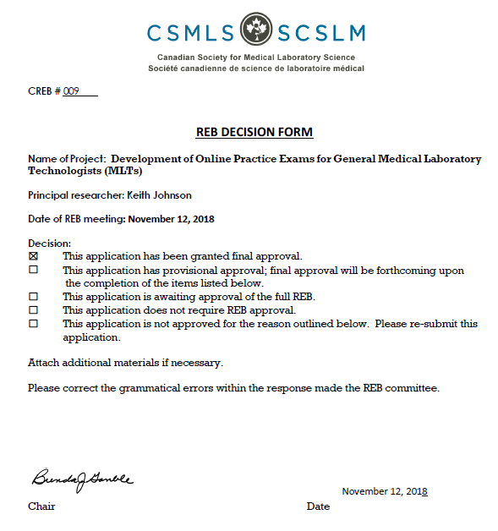

Appendix D: Numeric Reporting Template

Performance Measure | Target | Total Results
Number of practice tests to be developed | 3 | 4
Number of individual test questions to be developed | 600 | 840
Number of IEMLTs who will participate in the pilot test phase | 75 | 115
Number of IEMLTs who will participate in the pilot test phase and go on to achieve licensure | 34 | 37
Number of IEMLTs who will participate in the pilot test phase and go on to obtain employment | 32 | N/A
Total number IEMLTs who will benefit from the project on an on-going basis. | 150 annually | 165 annually

See K. Johnson & B. Baumal, “Assessing the Workforce Integration of Internationally Educated Health Professionals” (2011), CSMLS: https://www.csmls.org/csmls/media/documents/publications/CSMLS-KS-0001_WFI_Report_ENG.pdf

